3 Bean Chili
Grocery List
- ¼ C EV Olive Oil
- ½ Red Onion, diced
- 1 Yellow Onion, diced
- ½ Red Bell Pepper, chopped
- 1 Green Bell Pepper, chopped
- 2 cloves Garlic, chopped
- 1 stalk Celery, diced
- 2 Jalapenos, seeded and diced
- 2 C Black Beans*
- 1 ½ C Navy Beans*
- 1 ¾ C Cannelini Beans*
**If using canned beans, fully drain the black and navy beans and rinse them. Lightly drain the cannellini beans.
- 2 Tsp. Tomato Paste
- 796ml can Diced Tomatoes
- 2 ¼ C low sodium Veg Stock
- Sea Salt / Black Pepper

S P I C E BLEND
- ½ Tbsp. Chili Powder
- ½ Tsp. Cayenne Pepper
- ½ Tsp. dried Oregano
- 1 Tsp. ground Cumin
- Good pinch crushed chili flakes

Prep Time: 20 Min
Cook Time: 1 Hr 10 Min +
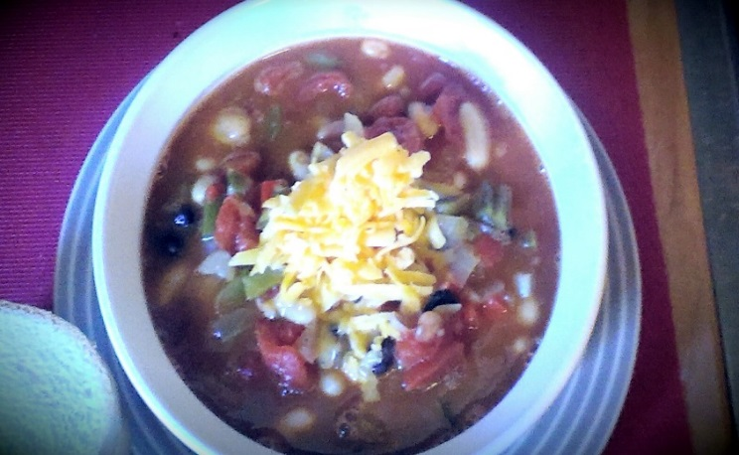
- Combine all the spices for the chili spice blend in a small dish. Stir to mix and set aside.

- Bring a large sauce pot to temperature on medium heat. Pour in the olive oil and add in the red and yellow onion, garlic, and celery. Season with a good pinch of sea salt and black pepper and stir constantly for 5 minutes.

- Add in the green and red pepper and jalapenos. Add another pinch of salt / pepper and stir together. Cover and continue frying on medium for 4 or 5 minutes stirring occasionally.

- Using a wooden spoon, make a circle in the center of the pan and drop in the tomato paste. Give it a minute to fry and heat up before stirring everything together. Add in the stock, can of diced tomatoes, all the beans, and the spice blend you combined earlier. Give 2 good pinches of sea salt and a good pinch of Black Pepper. Cover and bring to a boil on medium high heat and continue boiling for about 15 minutes.

- Reduce to medium low and continue cooking covered for another 15 minutes. Remove the lid and allow the chili to simmer for at least 30 minutes to reduce some of the liquid.

- Serve garnished with shredded cheddar cheese.

