Broccoli, Cheddar, and Mashed Potato Casserole
Grocery List
- 5 Russet Potatoes
- 3 Tbsp. Unsalted Butter
- 3 Tbsp. 2% Milk
- ¾ C shredded Cheddar Cheese (Medium – Sharp)
- 2 Tbsp. fresh Curly Parsley, chopped
- Sea Salt / Black Pepper

- 10 Mini Potatoes, red / white, sliced
- 3 Tbsp. EVOO
- 3 cloves Garlic, sliced
- ½ Yellow Onion, diced
- 1 Tbsp. fresh Curly Parsley, chopped
- Sea Salt / Black Pepper

- 2 C Broccoli Florets
- ¼ C low sodium Vegetable Stock
- 1 Tsp. Unsalted Butter
- ¼ Yellow Onion, diced
- Sea Salt / Black Pepper

- ¾ C shredded Cheddar Cheese (Medium – Sharp)

Prep Time: 25 Min
Cook Time: 1 Hr.
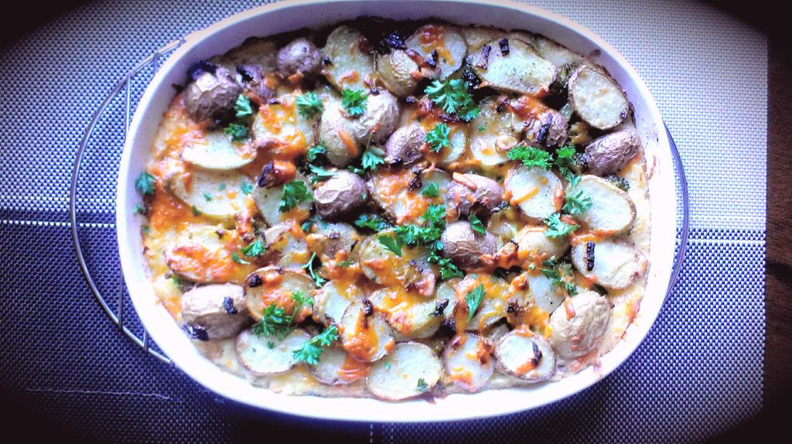
- Bring a large saucepan filled with cold water to a boil on medium high heat. Thoroughly scrub the Russet potatoes and drop them into the boiling water. Boil 25 – 30 minutes or until easily pierced with a fork. Strain and transfer to a large mixing bowl.

- Give the potatoes a mash or two to start the process. Add 1 Tbsp. of butter / milk and mash again a couple of times. Repeat 2 more times with the butter / milk / mash. Dump in the ¾ C cheddar cheese and fresh parsley. Whip together with a fork. Season with salt and pepper and set aside.
**Potatoes should be fairly stiff, if they are too runny all the toppings will sink into them.

- In the meantime, bring a large frying pan to temperature on medium. Pour in the EVOO and swirl around the pan. Add the onion and sliced garlic to the pan and fry 2 minutes before adding the sliced mini potatoes. Fry 10 minutes approximately stirring and flipping often. Cover and set aside.
**Potatoes should be lightly browned and slightly underdone.

- In a small saucepan on medium, melt the butter and add the diced onions. Fry only a couple of minutes before pouring in the vegetable stock and broccoli florets. Give a pinch of sea salt / pepper and cover for 7-10 minutes until broccoli begins to become tender.

- Preheat oven to 375 F

- In a 1 ½ qt. shallow baking dish, rub unsalted butter all over the dish. Add the mashed potatoes to the dish and spread across the dish fairly evenly. Use a serving spoon to transfer the broccoli / onion mixture draping it over the mashed potatoes making sure to get some of the stocky mix as well to keep the potatoes moist. Sprinkle half the 3/4 C cheddar cheese across the dish. Line the sliced potatoes over the entire dish making sure to pick up some of the fried garlic / onions as well. Sprinkle with the remaining cheddar cheese.

- Bake uncovered 20 – 25 minutes. Finish under the broiler for 3-4 minutes to achieve a golden brown and crispy top.

- Serve with fresh parsley.

