Brussel Sprout and Broccoli Bake
Grocery List
- 1 Head Broccoli, cut into florets (approx.. 2 – 2 ½ C)
- 2 C Brussel Sprouts
- 1 Yellow Onion, quartered
- 2 cloves Garlic, sliced
- 1 Tbsp. Unsalted Butter
- ¼ C low sodium Vegetable Stock
- Sea Salt / Black Pepper

- ¼ C Italian Bread Crumbs
- 2 Tbsp. Corn Flake Bread Crumbs
- Pinch Sea Salt
- 1 Tbsp. fresh Parsley, finely chopped
- 1 Tbsp. Unsalted Butter

- 1 ½ Tbsp. Unsalted Butter
- 1 Tbsp. AP Flour
- 1 Tbsp. Cream Cheese
- ½ C 2% Milk
- Sea Salt / Black Pepper

- ¼ C Marble Cheddar, shredded

Dressed in a creamy white sauce and buttery, toasty bread crumbs
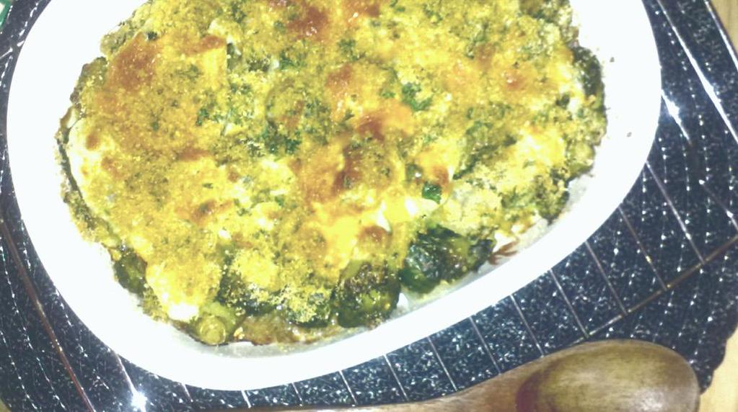
Prep Time: 20 Min
Cook Time: 50 – 60 Min

- In a medium sauce pan, combine the vegetable stock and 1 Tbsp. butter and bring to temperature on medium. Add in the Brussel sprouts and broccoli and a good pinch of sea salt and black pepper, stir and cover. Cook 8 minutes stirring occasionally.

- Stir in the sliced garlic and yellow onion, stir and cover cooking another 5 minutes. Remove from heat and leave covered.

- In a small mixing bowl, combine the breadcrumbs, flake crumbs, sea salt, and fresh parsley. Stir with a fork and set aside.

- In a small sauce pan, melt 2 Tbsp. butter on medium heat. Scoop out one tbsp. of butter and combine with the bread crumbs. Stir with a fork. To the pan, add the all purpose flour and stir. Allow to bubble a minute or so before stirring in the milk. Continuously stir as the mixture bubbles and thickens. Stir in the cream cheese and a pinch of sea salt / black pepper. Reduce heat and cook 5 minutes stirring occasionally.

- Preheat the oven to 350 F

- Use a 1 ½ qt. Baking dish and transfer the veggies to the dish. Make sure to drizzle the pan juice over them. Next, pour the creamy sauce over the vegetables in the baking dish. Sprinkle with the shredded marble cheese followed by the buttery bread crumbs.

- Bake uncovered 30 – 40 minutes until nice and brown on top and sprouts are easily pierced with a fork.

