Cannelini & Zucchini Shells
Grocery List
- 1 C Shell Pasta, uncooked
- ¼ C (+) Unsalted Butter, cubed
- 2 Tbsp. (+) EVOO
- 4 cloves Garlic, chopped
- Yellow Onion, diced
- Roma Tomato, diced
- Zucchini, halved lengthwise and sliced
- 540ml can Cannelini Beans, drained and lightly rinsed
- 2 Tbsp.(+) low sodium Vegetable Stock
- ¼ C Pasta Water
- ¼ Tsp. Red Pepper Flakes
- 10 – 15 fresh Basil leaves (+ for garnish)
- ¼ C fresh Curly Parsley, chopped
- 2 Tbsp. grated Parmesan cheese
- Sea Salt / Black Pepper

** (+) More if necessary.

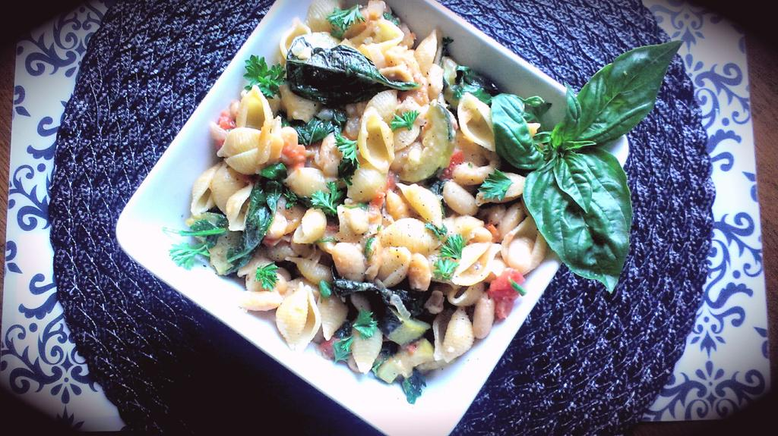
A blend of cannellini beans, zucchini, fresh herbs, and tomato make for a delicious “sauce” to combine the shell pasta with. Serves 4
Prep Time: 15 Min
Cook Time: 30 Min

- Bring a large pot of cold water to a boil on medium high heat, season liberally with sea salt once boiled. Cover until it is time to cook pasta.

- Bring a large frying pan to temperature on medium. Pour in the EVOO and ½ the cubed butter. Once melted and bubbly, add the garlic and stir often for 2 minutes before adding the onion and a good pinch of sea salt / pepper. Fry 3 or 4 minutes stirring often.

- Add the zucchini and tomato and another good pinch of salt / pepper. Cover, stir often, and cook about 8 – 10 minutes until veggies are tender. During this time you may need to add a few more cubes of butter depending on how much “sauce” you see at the bottom of the pan.

- Add the pasta to the boiling, salted water and cook to al dente according to package directions. Reserve ¼ Pasta Water, strain but do not rinse the noodles.

- Make a circle in the center of the pan and sprinkle the red pepper flakes in. Give them a minute to fry up in the sauce before stirring them in. Add the cannellini beans, vegetable stock, pasta water, and fresh herbs. Give another pinch of sea salt and stir to combine. Cover and allow to bubble away 4 minutes or so until beans are heated and everything is combined. Add in the cooked pasta and parmesan cheese, stir and cover another minute or 2 to marry all flavours.

**You may need to add more oil, stock, or butter depending on how thick the mixture is and your desired sauciness. If your beans overcook the dish will get starchy at which point you will need more stock.

- Pour straight from pan into desired serving dish. Garnish the dish with a drizzle of EVOO, fresh parsley and basil, and more parmesan if you desire.

