Caprese Pasta Salad
Grocery List
- 4 C Rotini Pasta
- 130 g container Bocconcini Pearls
(about 12 – 14 Pearls)
- 1 pint Medley Tomatoes, halved
- 5 fresh Basil Leaves, rolled and sliced
- ¼ C loosely packed Parsley, roughly chopped
- 2 Tbsp. diced Red Onion
- Sea Salt / Pepper
- 1 Tbsp. Balsamic Vinegar

DRESSING

- 1/3 C EVOO
- 2 Tbsp. Balsamic Vinegar
- 1 clove Garlic, crushed and pressed (or minced)
- ¼ Tsp. dried Parsley
- 1/3 Tsp. dried Basil
- 1/3 Tsp. Sea Salt
- ¼ Tsp. Black Pepper

Dressed in a fresh Balsamic Vinaigrette

Prep Time: 15 Min
Cook Time: 10 Min
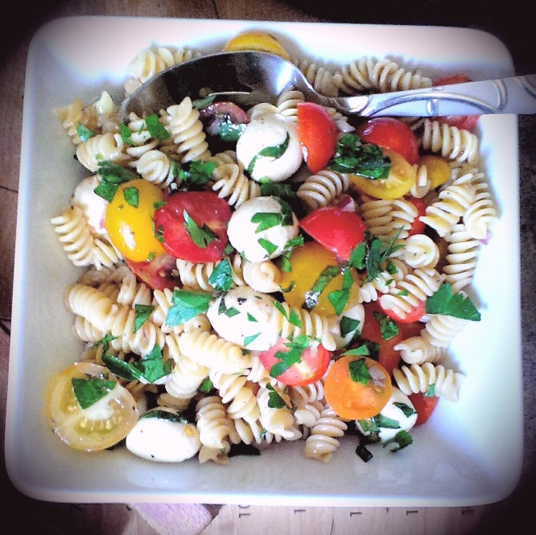
- Fill a large sauce pan ¾ the way full with cold water and set to medium high. Once boiled, season liberally with sea salt and add the pasta. Cook to Al Dente (approximately 8 minutes) and strain. Rinse with cold water to stop the cooking process.

- In a small mixing bowl, whisk together all ingredients for the dressing. Set aside.

- In a large mixing bowl, add the cooked pasta, halved medley tomatoes (quartered for the larger ones), red onion, and bocconcini’s. Drizzle the dressing over the pasta and toss to combine.

- Sprinkle in the basil and ¾ of the chopped parsley and toss once again to combine. Add a pinch each of sea salt and black pepper and the final Tbsp. of Balsamic vinegar. Toss again to fully mix everything together.

- Transfer to a serving dish and sprinkle with the remainder of the chopped parsley.

**I recommend chilling the salad for an hour to really enjoy it at its best!

