Cheesy Black Bean Roasties
Grocery List
- 6 Russet Potatoes, diced
- EV Olive Oil
- Sea Salt
- ½ Lime Zest

- ¼ C EV Olive Oil
- ½ Yellow Onion, diced
- ½ Red Bell pepper, diced
- 2 cloves of Garlic, minced
- 1 Roma Tomato, diced
- ½ 540ml can Black Beans, lightly drained
- 1/3 C frozen sweet Corn
- Pinch Red Pepper Flakes
- ½ Tsp. ground Cumin
- 1 Tsp. Hot Sauce
- 1 Tbsp. Chili Powder
- Sea Salt / Black pepper
- ½ Lime, juice and zest

- 2 Roma Tomatoes, seeded and diced
- ½ Red Onion, diced
- 1 Lime, juice and Zest
- Sea Salt

- 1 ½ C shredded Cheddar Cheese

Prep Time: 25 Min
Cook Time: 40 Min
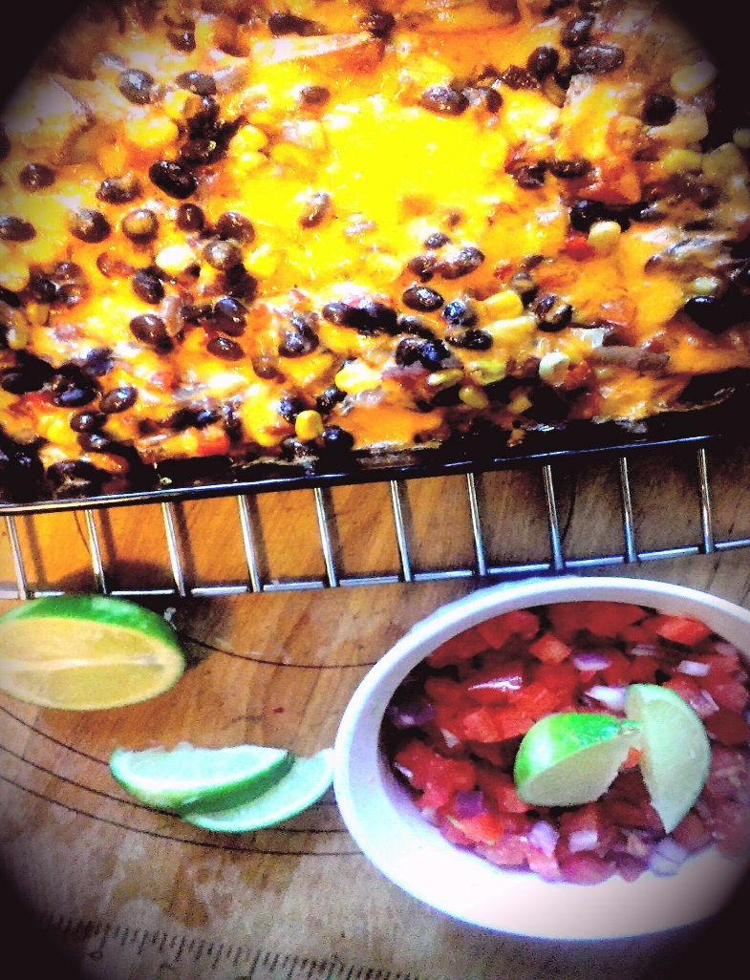
- Preheat oven to 425 F

- Line the diced potatoes evenly over a baking sheet and drizzle with olive oil. Give a generous pinch of sea salt and toss them around to coat them. Bake for 15 Minutes until golden brown on both sides flipping half way. Remove and zest some lime over them.

- Reduce oven to 375 F

- In a small sauce pan, bring to temperature on medium and pour in the olive oil. Add in the diced yellow onion, red pepper, and garlic. Season with a pinch of sea salt and fry for 5 minutes. Add in the diced tomato and continue frying another 2 minutes. Pour in the beans, corn, chili powder, pepper flakes, lime juice and zest, hot sauce, cumin, two pinches of sea salt and a pinch black pepper. Bring to a boil and reduce heat to medium low. Cover and cook for about 15 minutes. Remove lid and cook 5 minutes to reduce liquid.

- Lightly oil an 11 x 7 baking dish. Start with the roasted potatoes creating an even layer. Ladle the bean mixture over the entire dish. Top with the shredded cheese.

- Bake for approximately 15 minutes until cheese is slightly browned and dish is nice and bubbly.

- In a small bowl, combine the tomatoes, onion, lime juice / zest, and a good pinch of sea salt. Top each serving of the bean and potato dish with the tomato mixture.

