Creamy Stuffed Mushrooms
Grocery List
- 17 White Stuffer Mushrooms
- 250g Cream Cheese
- 2 Tbsp. EVOO
- 1 Tbsp. Unsalted Butter
- 1/4 Red Onion, diced
- ¼ C Red Pepper, diced
- 1 clove Garlic, minced
- ½ C Marble Cheddar, shredded
- 2 Tbsp. fresh Parsley, finely chopped
- 2 Green Onions, light and dark green, sliced
- ¼ C seasoned Breadcrumbs
**I prefer Italian style breadcrumbs. If using plain breadcrumbs, season with dried herbs and salt
- Sea Salt / Black Pepper

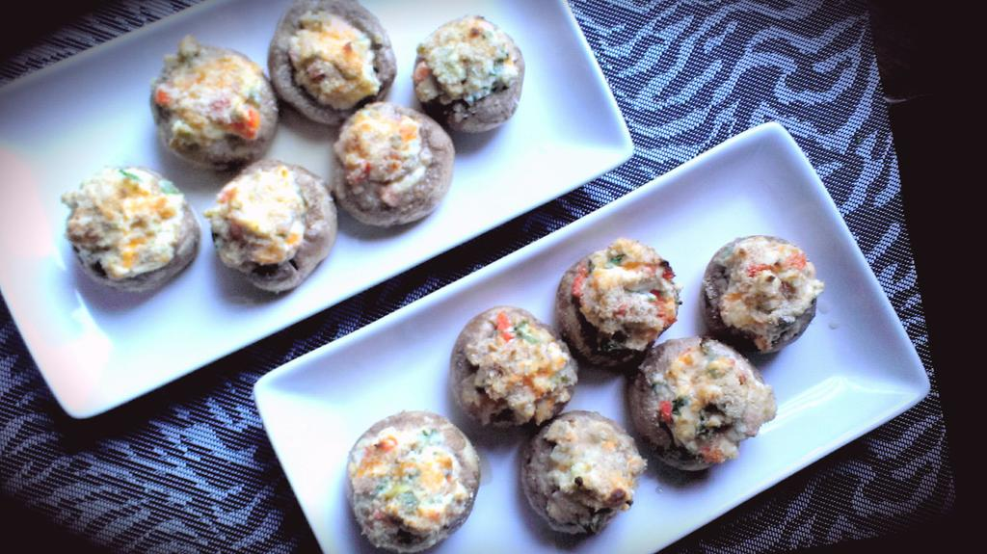
Prep Time: 20 Min
Cook Time: 15 - 18 Min

- Thoroughly wash the mushrooms, pat dry, and remove the stems revealing the perfect crater for stuffing. Chop up half the stems removing the tough portions. (Store the remainder of stems for another dish or use them all if you like!)

- In a large frying pan, bring to temperature on medium and add the EVOO and butter to the pan. Stir in the red onions and red pepper and season with a pinch of sea salt. Fry 4 minutes before adding the chopped mushroom stems and garlic. Stir often and fry another 3 – 4 minutes. Remove from heat and transfer to a bowl to cool for 5 minutes.

- Preheat oven to 425 F

- In a small mixing bowl combine the cream cheese, marble, parsley, green onion, pinch of both sea salt / black pepper, and fried veggie mixture. Use a tablespoon (and you’re fingers!) to scoop the mixture into the mushrooms until heaping. Sprinkle sea salt over the mushrooms.

- Dump the breadcrumbs on to a plate and hold the mushroom over the plate while generously sprinkling the mushrooms with crumbs. Shake off excess and line on an ungreased baking sheet.

- Bake 8 – 10 Minutes.

