Crispy Panko Onion Petals
Grocery List
- 4 Yellow Onions
- 3 C Panko Bread Crumbs
- 1 Tbsp. Sea Salt
- 1 Tsp. Black Pepper
- ½ C finely chopped fresh Parsley
- ½ C 2 % Milk
- ½ C AP Flour
- Canola Oil – for frying

Prep Time: 20 Min
Cook Time: 7 – 10 Min
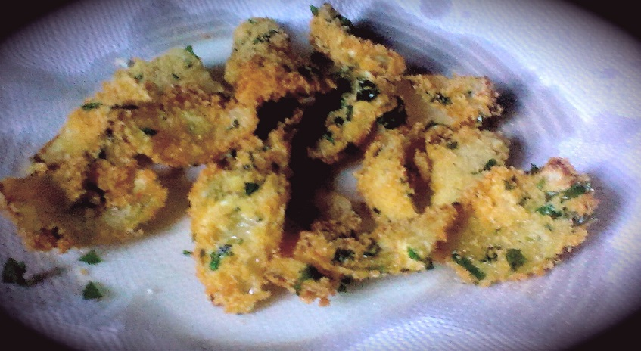
- Slice both the ends off the onions and slice them in half lengthwise. Slice each half in 3 equal parts and separate the “petals” removing as much of the plasticy, sticky skin between the layers.

- Line a small plate with the AP Flour and a separate bowl with the milk. Combine the breadcrumbs, salt / pepper, and fresh parsley in a medium sized mixing bowl. Stir together using a fork.

- Fill a large frying pan 1/3 the way full with Canola Oil and begin heating on just over medium. (If you have a thermometer, temp at approximately 375)

- Dredge the onion petals in the flour, transfer to the milk and follow by dredging in the panko mix. Repeat until all petals are breaded and lined on baking sheets.

- Test the oil using one petal slowly dipping into the oil. If it bubbles up immediately upon hitting the oil you are good to go! Fry the petals in batches in a single layer for 2 minutes per side (watch for browning). Transfer to a paper towel lined plate and immediately season generously with sea salt. Repeat until all petals are cooked.

The petals cook quickly BUT
**Keep the oven on 325 and leave the cooked petals in there to keep them warm between batches.
**Or, transfer the petals from the paper towel lined plate to another plate and use a pan lid to keep it warm.

