Eggplant Parmesan
Grocery List
- 1 large Eggplant, 10 – 12 slices

- ¼ C EV Olive Oil
- 1 Tbsp. unsalted Butter
- 1 yellow Onion, diced
- 1 medium Carrot. Diced small
- 1 stalk Celery, diced
- 796ml can diced Tomatoes
- 3 cloves Garlic, minced
- 3 or 4 Basil leaves, rolled up and sliced
- Bunch fresh Parsley (about ¼ C)
- Sea Salt / Black Pepper
- ¼ Tsp. Sugar

- ¼ C Panko bread crumbs
- ¼ C Italian bread crumbs
- 2 C shredded Mozzarella
- 4 Tbsp. grated Parmesan

- Spaghetti (approximately 50g uncooked pasta / person)

Prep Time: 25 Min
Cook Time: 1 Hr
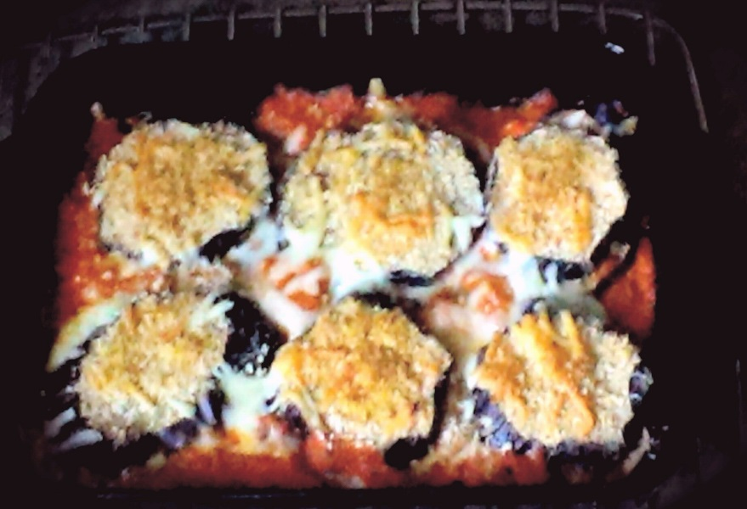
- Preheat oven to 425 F

- Lay the slices of eggplant on an ungreased baking sheet. Drizzle with olive oil and sprinkle each slice with sea salt and black pepper. Bake for approximately 10 minutes (look for browning and slight wrinkling) Remove and transfer eggplant to paper towels for a minute or 2. Transfer to a plate until ready to use.
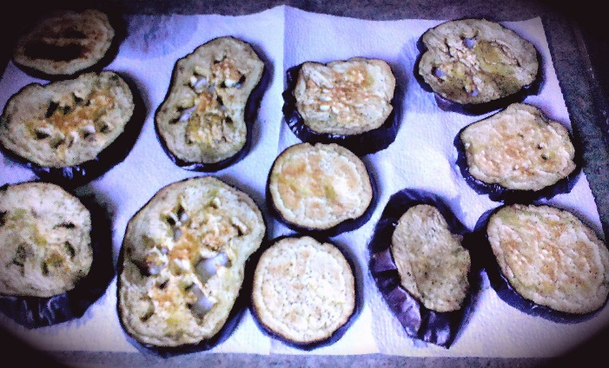

- Reduce oven temperature to 375 F

- In a large frying pan, bring to temperature on medium and add the oil and unsalted butter. Add in the celery, onion, carrot, a couple pinches of salt. Fry for 6 or 7 minutes stirring often. Add in the minced garlic and another pinch of salt. Continue frying another couple minutes before adding the canned tomatoes, fresh basil / parsley, sugar, and about a Tsp. sea salt and ½ Tsp. black pepper. Bring to a boil on medium, reduce to medium low and cook covered 20 minutes or until all veggies are tender.

- Transfer sauce to a large mixing bowl. Using an immersion blender, blend the sauce until thick and smooth. Return to pan and adjust seasoning after tasting. Keep covered on low until ready to use.

- In a small bowl, combine panko / Italian crumbs using a fork to stir together. Set aside.

- In a lightly oiled 11 x 7 baking dish, line the 6 largest slices along the bottom of the dish. Sprinkle half the mozzarella evenly over each slice of the eggplant. Give a sprinkle of bread crumbs over each slice (about ½ Tsp.) and a drizzle of the sauce. Sprinkle two Tbsp. parmesan over the entire dish. With the remaining 6 smaller slices, coat them fully in the bread crumbs before topping the 6 larger slices. Drizzle sauce in between each eggplant slice making sure to leave the tops of the crusted slices clear to brown in oven. Sprinkle with the remainder of the mozzarella cheese and grated parmesan.

- Bake uncovered 15 – 18 minutes until bread crumbs are nice and toasty brown and sauce is bubbling.

- Bring a large pot of salted water to a boil on high and add your spaghetti according to how many people will be eating. Cook according to package directions. Strain.

- Using tongs, make a swirl of spaghetti in the center of the plate. Drizzle with olive oil, sprinkle with sea salt and grated parmesan and a tiny drizzle of sauce. Place the two layered slices of eggplant on top of the pasta neatly. Serve and sprinkle with chopped fresh parsley and grated parmesan.

