Fried Zucchini Chips
Grocery List
- 2 Zucchinis sliced into about ¼ inch thick slices
- Approx. ½ C AP Flour
- ½ C 2% Milk
- ½ C Italian style Bread Crumbs ++
- ½ C Panko Bread Crumbs++
- ¼ C chopped fresh Parsley
- 1 Tbsp. dried Basil
- Sea Salt / Black Pepper
- Vegetable Oil (for frying)

Prep Time: 10 Min
Cook Time: 10-15 Min
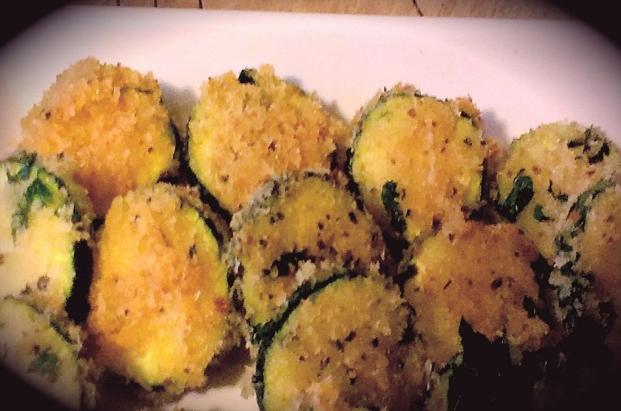
- Fill a medium sized frying pan ¾ of the way full with vegetable oil and heat on just above medium.

- Put the flour on a small plate. Pour the milk into a small bowl as well. In another small mixing bowl combine the panko and Italian crumbs, fresh parsley, dried basil, and a good pinch of sea salt and black pepper and stir together.

- First dip the zucchini slices in the flour coating them entirely, follow by dipping in the milk and rolling in the herby crumb mixture. Press the coating a little on to the zucchini if it is hesitating to stick.

- Use one slice to test the oil. If it starts to bubble immediately upon dipping it in the oil is likely ready. Fry the slices in 2 batches about 6 minutes approximately. (Look for golden brown!)

- Transfer to a paper towel lined plate and generously sprinkle with sea salt**

**Zucchini’s are fairly flavourless and extremely juicy. The salt is crucial. They really need to be salted generously to bring out their delicious flavour.

- Transfer to a serving plate and serve with a nice ranch dressing or enjoy them on their own as a nice change from french fries!

