Ricotta Gnudi &Pomodoro Sauce
Grocery List
SAUCE
- 1 796ml can Diced Tomatoes
- ¾ Yellow Onion, diced
- 3 cloves Garlic, chopped
- 1 Tbsp. chopped fresh Oregano
- 1 Tbsp. chopped fresh Basil
- 2 Tbsp. chopped fresh Parsley
- 1/3 C Extra Virgin Olive Oil
- 1 Tbsp Unsalted Butter
- Sea Salt / Pepper

GNUDI
- 475g Light Ricotta Cheese
- 1 Egg, beaten
- 1/3 Tsp. Nutmeg
- 1/3 C chopped fresh Parsley
- 1 Tsp. Sea Salt
- ½ Tsp. Black Pepper
- 1/3 C All Purpose Flour + more for plate and dusting

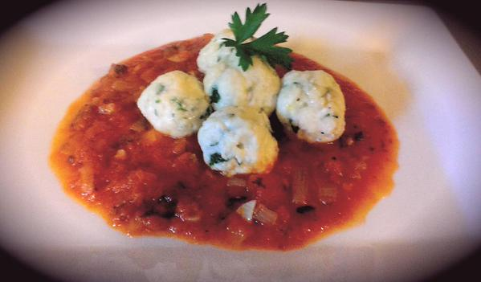
Prep Time: 15 Min
Chill Time: 2 Hours
Cook Time: 30 Min

- In a medium sized mixing bowl, add the ricotta cheese, egg, nutmeg, parsley, salt, and pepper and whip together with a fork. Add in the flour and mix together to form a sticky looking dough.

- Get a small plate out and scoop some flour onto it. Using a teaspoon, scoop the mixture into your hands and roll it in to balls. Roll the balls through the flour and transfer to a baking sheet lined with parchment paper and dusted with flour. Chill for 2 hours.

- Bring a large pot of generously salted water to a boil on high heat.

- In a small bowl, empty the tomatoes and blend together using an Immersion Blender (or a regular blender if you don’t have an Immersion handy.)

- In a large frying pan, melt the butter and olive oil together on medium low heat. Add the onions and a pinch of sea salt, fry for about 5 – 7 minutes without browning them. Add the garlic and stir, cook another 4 – 5 minutes.

- Add the herbs to the mixture and stir around to combine. Pour in the blended tomatoes and bring to a boil on medium heat stirring every minute or so. Reduce the heat to medium low and cover. Cook for another 15 minutes.

- Add the Gnudi to the boiling water in 2 batches. Cook the Gnudi for approximately 6 minutes (they might float after 3 minutes but cook them for at least 5 minutes)

- Drain them on a paper towel lined plate. Remove the paper towel and drizzle the Gnudi with Olive Oil.

- For service you may add the Gnudi to the sauce pan and dress them that way or simply lay them on a bed of sauce with a little sauce drizzled on top. Garnish with fresh Parsley.

