Italian Poutine
Grocery List
- 4 Russet Potatoes, scrubbed thoroughly

- 3 Tbsp. EV Olive Oil ++
- 2 C Halved Medley Tomatoes
- 1 small Yellow Onion, diced
- 3 cloves Garlic, minced
- 1 Zucchini, halved lengthwise and sliced
- ¼ C low sodium Vegetable Stock
- ¼ Tsp. Salt
- Just under a Tsp. AP Flour
- 1 Tbsp. Dried Basil
- 1 Tbsp. Dried Parsley
- Sea Salt, Black Pepper

- 1 Tsp. Sea Salt
- ½ Tsp. Black Pepper
- 2 Tbsp. chopped Fresh Basil
- 2 Tbsp. chopped Fresh Parsley
- 1 heaping Tbsp. grated Parmesan

- 4 Bocconcini, sliced thin

Prep Time: 15 Min
Cook Time: 20 – 25 Min
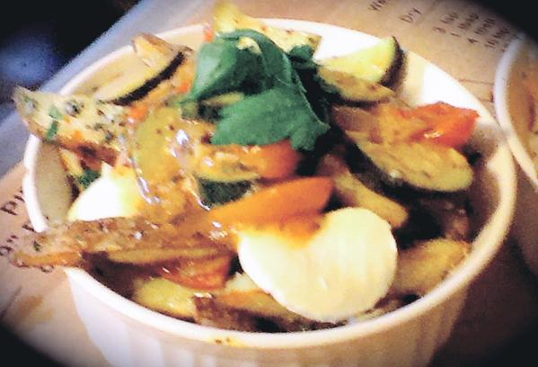
- Preheat oven to 425 F

- Slice the potatoes (lengthwise) into 4 approximately equal slices. Slice them again into steak cut sized fries. Line them on a baking sheet that has been drizzled with EV Olive Oil. Drizzle the fries with more oil and give a generous pinch of sea salt and black pepper to season. Bake for approximately 20 – 25 Min flipping halfway.

- In a small saucepan, bring to temperature on just under medium and add in the oil and diced onions. Give a pinch of sea salt / pepper and stir often for 5 minutes. Add in the minced garlic and continue frying another 2 or 3 minutes. Add in the tomatoes and zucchini, dried herbs, sugar, and another generous pinch of sea salt and black pepper. Cover and cook on medium for 5 minutes. Pour in the vegetable stock and cook covered another 5 minutes. Remove lid and continue cooking on medium low for 7 - 10 minutes (until veggies are tender)

- Strain the cooked vegetables into a bowl and stir in the All Purpose Flour. Allow the “sauce” to thicken and bubble a bit and return the cooked veggies back to the pot.

- Remove the fries from the oven. In a large mixing bowl, combine the sea salt, black pepper, basil, parsley, and parmesan. Add the fries to the bowl and toss to coat the fries.

- Depending on how you decide to serve (2 medium sized dishes with 2 sliced bocconcini each or 4 smaller, side dishes with 1 sliced bocconcini each.) Layer the bottom of the dish with the fries followed by half the bocconcini and a ladle of the veggies and sauce. Top with the remainder of the fries, cheese, and sauce.

- Garnish with fresh Parsley.

