Italian Quesadillas
Grocery List
- 8 Small Flour Tortillas
- 8 Slices Mozzarella (1 C shredded)
- 4 Tbsp. Ricotta Cheese
- 12 Grape Tomatoes, halved
- 12 fresh Basil Leaves
- 2 Tbsp. fresh Parsley, chopped
- Sea Salt / Black Pepper

- 2 C prepared Tomato Sauce

- 1 ½ Tbsp. Unsalted Butter
- 1 ½ Tsp. fresh Parsley, chopped
- 2 cloves Garlic, pressed / minced
- Sea Salt

Prep Time: Sauce Prepared – 10 Min
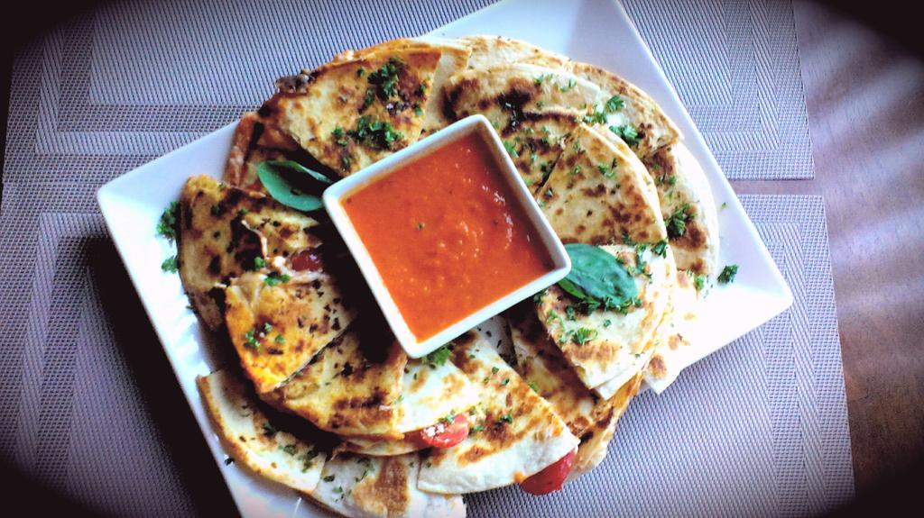
Sauce Unprepared – 20 Min

Cook Time: Sauce Prepared – 10 Min
Sauce Unprepared – 35 – 40 Min

- If you need to prepare the sauce, do so now prior to starting the quesadillas.

- In a small bowl, combine the room temperature butter with the garlic, parsley, and a pinch of sea salt. Use a fork to mash ingredients together.

- Line your work surface with a piece of parchment paper. Spread the garlicy butter on one side of 2 tortillas and lay them butter side down on the parchment to build.

- Spoon about a TBSP. of sauce onto each tortilla and spread around the tortilla leaving about a ½ inch from the edge. Break up 2 slices mozzarella to spread on each sauced tortilla (or ¼ C shredded per quesadilla). Follow by laying 3 basil leaves, 6 halves of tomato, ½ Tbsp. parsley.1 Tbsp. Ricotta dropped randomly across the tortilla, and a pinch of black pepper on one tort. Fold the 2nd tortilla over to form the quesadilla leaving the buttered sides on the outside for frying. Repeat until 4 Quesadillas are prepared.

- In a large frying pan, bring to temperature on medium before adding the first quesadilla. Fry about 2 minutes before flipping and finishing with another minute or 2. Transfer to a cutting board and start on the next quesadilla. Repeat until finished.

- Allow the quesadillas about 3 minutes to cool before slicing to keep them held together better, Cut the quesadilla in half. Slice each half into 3 wedges. Arrange on a serving platter served with the remainder of the warm tomato sauce. Garnish with fresh basil and parsley.

