Jalapeno Popper Dip
Grocery List
- 227g tub Cream Cheese
- 227g tub Jalapeno Cream Cheese
- ½ C Mayonnaise
- 2 Jalapenos, seeded and diced
- Green Onion, sliced
- 1 clove Garlic, pressed or minced
- Shallot, diced
- 2 Tbsp. Red Pepper, diced
- ¼ C Mozzarella, shredded
- ¼ C Medium Cheddar, shredded
- 1/3 Tsp. Sea Salt / ¼ Tsp. Black Pepper

- 1/3 C Plain Bread Crumbs
- 1 Tbsp. Fresh Parsley, finely chopped
- Pinch Sea Salt
- 1 Tbsp. Unsalted Butter

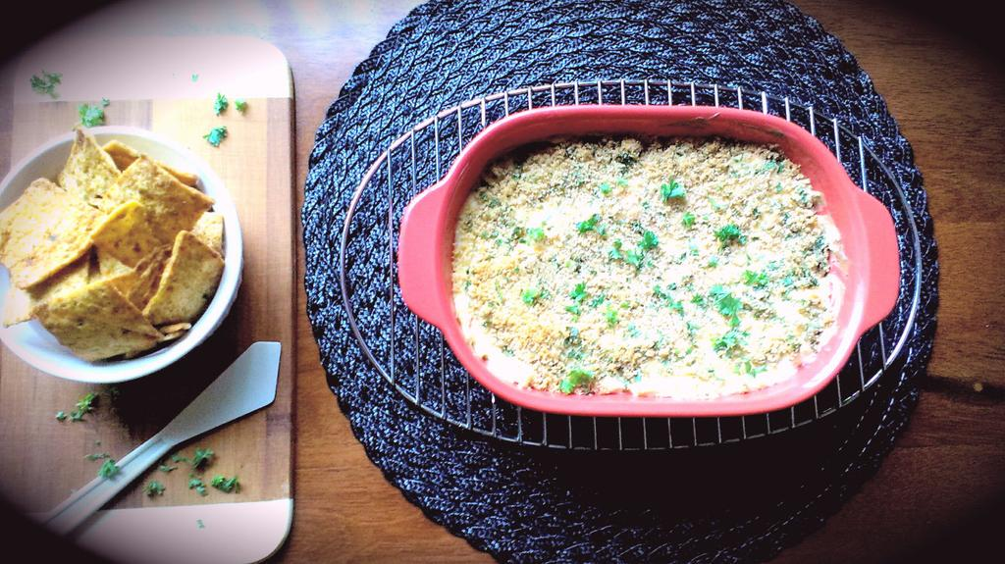
Prep Time: 15 Min
Cook Time: 20 – 25 Min

- Preheat oven to 350 F

- In a medium sized mixing bowl, combine all ingredients aside from crumb mixture. Whip together and transfer to a 1 ½ qt. baking dish. Use a spatula to spread evenly around the dish.

- In a small mixing bowl, stir together the bread crumbs, chopped parsley, and pinch of salt. Add the Tbsp. of butter to a small sauce pan and melt on medium low. Once melted, slowly pour the melted butter into the bread crumbs while stirring with a fork to combine.

- Sprinkle the buttery crumbs over the cheese dip and bake uncovered 20 – 25 minutes.

- Serve with crispy pita chips (or your favourite dipping chip)

