“Sausage” Jambalaya
Grocery List
- ¼ C EVOO
- 3 Veggie Sausages (Yves), sliced
- 1 Tsp. Cajun Seasoning

- 1 Bell Pepper, chopped
- 1 Red Onion, diced
- 2 stalks Celery, sliced
- 1 Green Onion, sliced
- 1 Jalapeno, seeded and diced
- 2 cloves Garlic, chopped
- 1 C canned, diced Tomatoes (including juice)
- 1 Tsp. Worcestershire Sauce
- 1 Tsp. Hot Sauce
- 2 Tbsp. + Cajun seasoning
- ¾ C long grain White Rice
- 1 ½ C low sodium Vegetable Stock
- Sea Salt / Black Pepper

CAJUN SEASONING
- 1 Tsp. Sea Salt
- 1 Tsp. Cayenne Pepper
- 1 Tsp. fresh Thyme
- 1 Tsp. dried Oregano
- ½ Tsp. minced Onion
- ½ Tsp. Garlic Powder
- ½ Tsp. Black Pepper

Prep Time: 10 Min
Cook Time: 45 Min
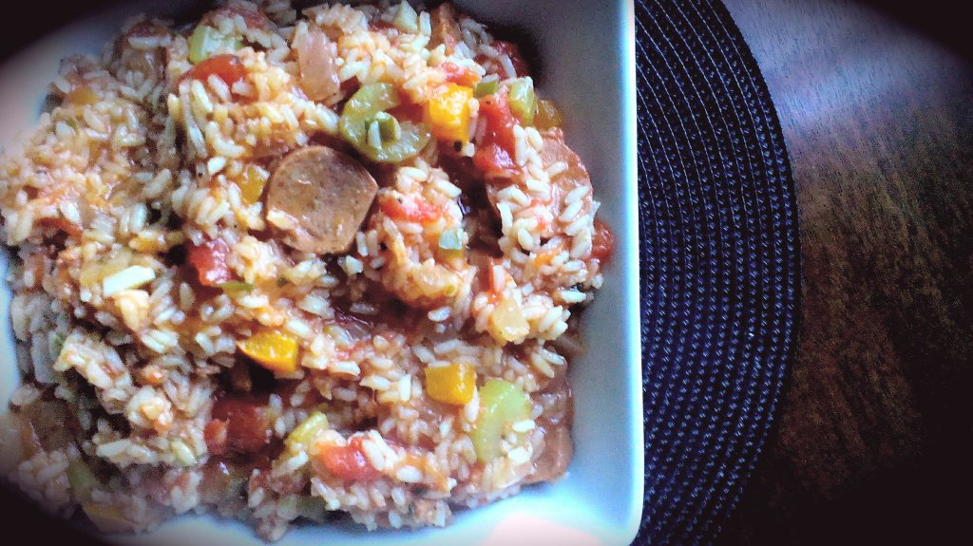

- In a medium sized sauce pot, bring to temperature and add half the oil. Add the sliced sausages and 1 Tsp. seasoning. Fry over medium heat stirring often for 3 – 4 minutes until browned. Transfer fried sausages to a separate bowl.

- To the same pot, add the remainder of the oil. Add the onion, green onion, pepper, jalapeno, celery, and garlic. Give a generous pinch of sea salt and black pepper and fry over medium heat 5 – 7 minutes.

- Stir in the diced tomatoes, worcestershire sauce, sliced sausages, and hot sauce. Simmer 10 minutes on medium low.

- Return to medium and add the rice, vegetable stock, and 2 Tbsp (minimum) Cajun seasoning. Bring to a boil, reduce heat to medium low, cover and simmer 20 minutes stirring occasionally.

- Taste and adjust salt / Cajun seasoning to taste. Garnish with sliced green onion.

