Fresh Corn and Leek Mashed Potatoes
***Jazzed Up Mash
Grocery List
- 6 White Potatoes
- 1 Cob Peaches and Cream Corn
- 1 Leek, sliced
- 2 Tbsp. Unsalted Butter +
- 3 Tbsp. Heavy Cream
- ¼ C 2% Milk
- Sea Salt / Black Pepper
- 1 Tbsp. fresh Parsley, chopped
- EVOO

Prep Time: 15 Min
Cook Time: 25 Min
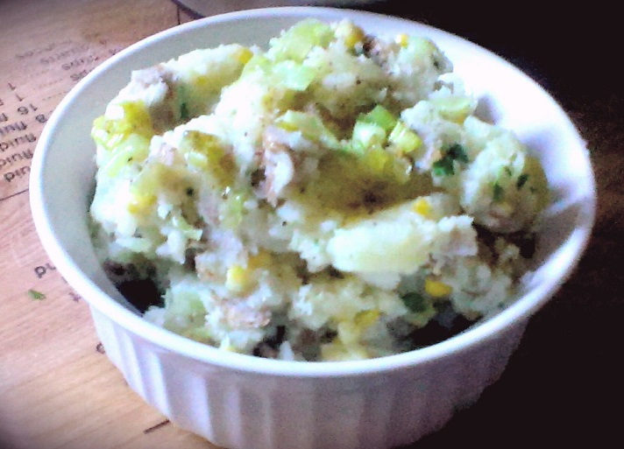
- Bring a large pot of water to a boil on high heat. Drop in your potatoes and tilt the lid for approximately 20 minutes. (remember the fork test)

- In a small frying pan, bring to temperature on medium and add ½ Tbsp. unsalted Butter and a drizzle of EVOO. Add in the leeks and a pinch of sea salt and pepper. Fry 5 to 7 minutes until leeks are tender. Remove from heat and cover.

- When potatoes have about 5 minutes left, add the cob of corn to the boiling pot. Once cooked, strain potatoes / corn.

- In a large mixing bowl, add the potatoes and give a mash or two with the potato masher. Add 2 Tbsp. heavy cream and 2 Tbsp. unsalted butter and mash a few more times to combine everything. Slowly add in the milk while mashing until the potatoes are the right consistency.

- Slice the corn from the cob and add it to the bowl. Stir in the fried leeks, fresh parsley, the final Tbsp. of heavy cream and a generous pinch of sea salt and black pepper. Drizzle with EVOO and stir to combine. Serve immediately.

