Mashed Potato Pancakes with Garlic Chive Butter
Grocery List
BUTTER
- ½ 454g stick of Unsalted Butter, cut into cubes
- 7 g Chives (about ¼ C)
- 2 cloves Garlic, crushed
- Pinch Seal Salt, Black Pepper

POTATOES
- 8 Russet Potatoes, peeled
- ¼ C Heavy Cream
- Tbsp Unsalted Butter
- 2 Tbsp EV Olive Oil
- Sea Salt, Pepper, Dried Parsley

- 1 Large Egg
- 1 C Shredded Marble Cheddar
- 2 ½ - 4 Tbsp All Purpose Flour
- 1 – 2 Green Onions, light and dark, sliced (some reserved for top)
- Sea Salt / Pepper

Prep Time: 25 Min
Cool Time: 3+ Hours
Cook Time: 25 – 30 Min for the Mashed
13 – 17 Min for Frying

- In a food processor, combine the cubed butter, chives (sliced in half), crushed garlic cloves, and the salt / pepper to taste. (2 Salt to 1 Pepper) Pulse until creamy and all ingredients are combined.

- Lay out a piece of plastic wrap and scoop the butter onto the outside edge. Pull the plastic wrap over the butter and begin to roll the butter back and forth into a log shape. Once you have the desired shape, roll up in the plastic wrap and toss in the fridge until ready to use.
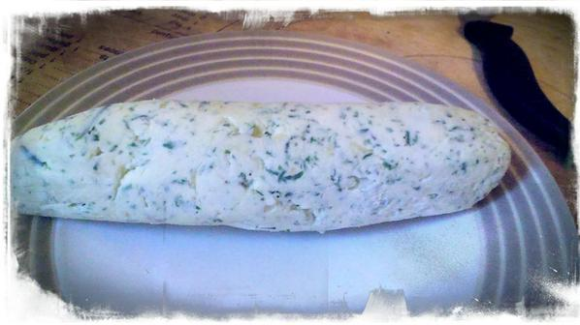

- Fill a large saucepan ¾ of the way with cold water and sprinkle a generous amount of sea salt. Bring to a boil on medium high heat and cover with the lid tilted. Boil for 20 – 25 minutes or until cooked. (FORK TEST after 20 minutes) Strain, and transfer the potatoes to a large mixing bowl.

- Add in the butter cubes and mash a few times. Add in the cream, olive oil, and season with 1 tsp salt, ½ tsp black pepper and dried parsley. Mash until relatively lump free. Refrigerate for at least 3 hours prior to using.

- Remove the potatoes from the fridge. To the mixing bowl add 1 large egg and stir in the flour (2 ½ Tbsp with day old Pots and up to 4 Tbsp in moister, same day potatoes), shredded cheese, and green onions.
**Using day old mashed potatoes is best as they are denser and lose some of their moisture. If you are using fresher ones, make sure to refrigerate for ATLEAST 3 hours.

- In a large frying pan, heat about 1 Tbsp unsalted butter and 1 Tbsp EV Olive Oil on medium heat. Using an ice cream scoop, place 4 dollops in the frying pan at once. After about a minute of frying, use a spoon to gently smash the pancakes into a flatter shape. Continue frying another 2 minutes until brown and flip over. Fry another 2 -3 minutes and transfer to a plate. **Makes approximately 14 pancakes so you will do roughly 4 batches**

- For service, slice the garlic and chive butter and lay the disks on top of the 2 – 3 pancake stack. Sprinkle with some sliced green onion and serve with a side of low fat sour cream.
