Mexican Stuffed Peppers
Grocery List
- 3 Mixed Coloured Bell Peppers
- 1 ½ C Prepared Mexican Rice
- Shredded Tex Mex Cheese
- Chopped Green Onions

Prep Time: 12 Min
Cook Time: 25 – 30 Min
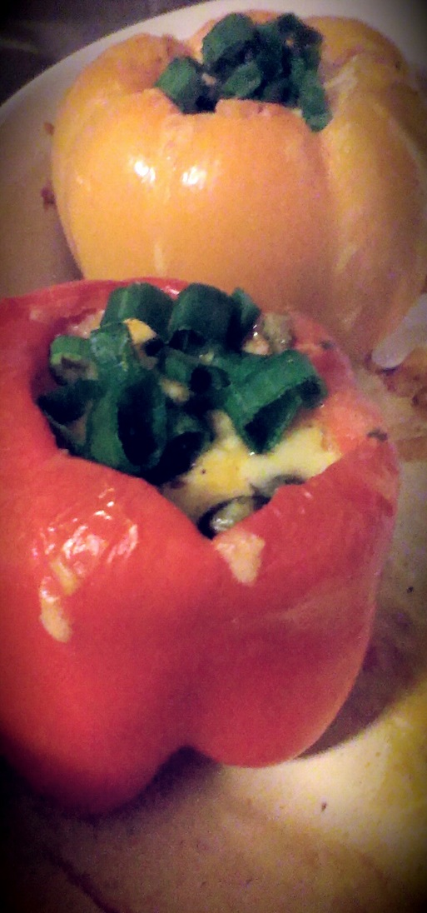
- Cut the tops of the peppers off and remove as much of the white portions as you can while removing the seeds. Rinse thoroughly with water.

- In a large saucepan, fill with cold water and bring to a boil on high. Drop the peppers in, cover, and boil for 3 – 5 minutes.

- Remove the peppers and put on an ice bath to prevent further cooking.

- Preheat oven to 375 F

- In a 2 ½ qt baking dish, place the peppers upright and put a Tbsp of the shredded cheese in the bottom of the pepper. (If you don’t have shredded Tex Mex you could always use shredded cheddar or Monterey jack.)

- Scoop approximately a ½ cup of the prepared rice into the pepper. (Filling should reach just below level with the top of the pepper) Top with a generous amount of shredded cheese.

- Place about 4 tbsp of water in the bottom of the dish and cover the dish with tinfoil. Bake for about 25 minutes. (AFTER 20 MIN, USE A FORK AND PIERCE THE PEPPER, IF IT EASILY SLIDES THROUGH, IT’S DONE)

- Top with chopped green onions and serve.

