Mexischetta
Grocery List
- 1 French Baguette, halved
- ¼ C EVOO
- 1 clove Garlic, pressed (or minced)
- 1 Jalapeno, seeded and sliced thin

- 540ml can Black Beans, drained and rinsed
- 13 Grape Tomatoes, halved
- ¼ C Red Onion, diced
- 2 Tbsp. fresh Cilantro, chopped
- 1 Lime, juice and zest
- 3 Tbsp. EVOO
- Sea Salt / Black Pepper

- 1 ½ C Monterey Jack, finely shredded
- 1 Avocado, mashed

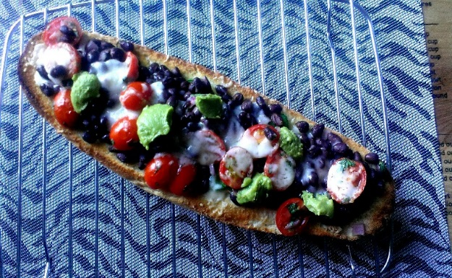
Prep Time: 15 Min
Chill Time: 45 Min +
Cook Time: 10 -12 Min

- Combine all the ingredients for the bean salad topping. Cover and refrigerate for at least 45 minutes to combine flavours.

- Set the oven to BROIL on 500 F

- In a small mixing dish, combine the ¼ C EVOO and crushed garlic. Whisk together and brush over both halves of the baguette. Line the sliced jalapenos along each half ensuring each slice will receive one. Place in oven under broiler for 4 minutes until browning begins.

- Split the cheese in half. Use the first half to sprinkle over both halves and return to the broiler for 2 minutes.

- Spoon the bean mixture over both halves of the bread and sprinkle the remainder of the cheese over the tops of both halves. Return to the broiler for 4 to 5 minutes and remove.

- Spoon the mashed avocado sporadically across the Mexischetta. Slice and serve immediately.

