Minestrone Soup
Grocery List
- 5 ¾ C low sodium Vegetable Stock
- ¼ C EV Olive Oil
- 2 Tbsp. Unsalted Butter
- 1 Leek, sliced
- ½ Yellow Onion, diced
- 4 cloves Garlic, minced
- 1 C Baby Carrots, sliced
- ¾ C Celery, sliced
- 19 oz can whole Tomatoes
- 1 Zucchini, halved lengthwise and sliced
- 1 C Snow Peas
- 540 ml can Cannellini Beans, drained and rinsed
- 2 C Baby Spinach (excess stem removed)
- 1 Tbsp. Tomato Paste
- ¼ C fresh Parsley, chopped
- 1 ½ Tsp. dried Basil
- 1 Tsp. Dried Oregano
- Sea Salt / Black Pepper

- Shell Pasta Noodles (1 C noodles = 2 ½ servings soup)

- 2 C Cubed Sourdough Bread
- EV Olive Oil
- Sea Salt / Black Pepper
- Dried Basil
- Freshly chopped Parsley

With crispy sourdough croutons

Prep Time: 25 Min
Cook Time: 45 Min+
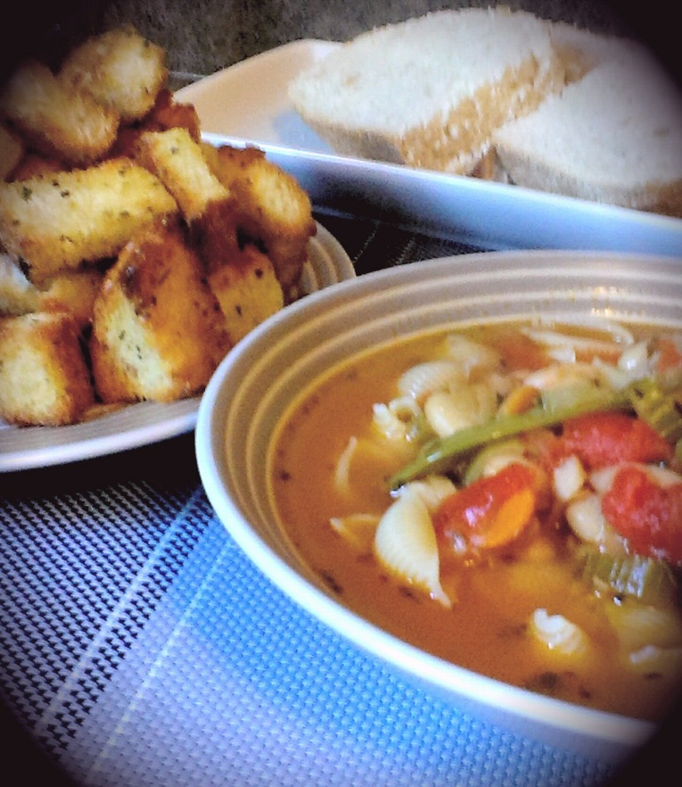
- Bring a large sauce pan to temperature on medium heat and add in the oil and butter. Add the leeks, onion, and garlic and a generous pinch of sea salt and black pepper. Fry for 5 minutes stirring often.

- Add in the carrots and celery and give another pinch of salt and pepper. Continue cooking another 3 or 4 minutes stirring often.

- Pour in the tomatoes and use a potato masher to mash them up in the pan. Pour in the vegetable stock and add a Tsp. of Sea Salt and 1/2 Tsp. Black Pepper. Also add the basil, parsley, oregano, and tomato paste. Stir and bring to a boil on medium high heat.

- Once boiled, reduce to medium and add in the zucchini, peas, cannellini beans, and spinach. Give a pinch of salt and pepper once again and allow to gently boil for 5 minutes. Reduce to medium low and cover. Simmer for at least 30 minutes.

- Preheat oven to 425 F

- Line a baking sheet with the cubed sourdough bread and give a generous drizzle of olive oil to coat the bread. Flip the bread to ensure a good coat on both sides. Generously season with sea salt and pepper, about a Tsp. Dried Basil and 2 Tsp. Freshly chopped parsley. Bake for about 15 minutes flipping throughout the cooking process.

- In a large sauce pan, fill ¾ with cold, salted water and bring to a boil. Cook shell pasta to al dente according to package. Do not over cook the noodles as the soup will also continue cooking them and you don’t want them to be mush. Strain and rinse the noodles under cool water.

- For service, I used an ice cream scoop and gave two scoops pasta per bowl. Drizzle the pasta with a little olive oil in the bowl and ladle the soup over the noodles. Garnish with the sourdough croutons.

