Mom’s Creole Style Rice
Grocery List
- 1 C Long Grain White Rice
- 2 C Low Sodium Vegetable Stock
- ½ C Kidney Beans
- ½ C Corn
- 2 Stalks celery, diced
- ½ Yellow Onion, diced
- 3 cloves Garlic, minced
- 7-10 Grape tomatoes, halved
- Salt, Pepper
- Fresh Parsley, chopped
- 1 Tbsp Chili Powder
- Paprika
- Olive Oil
- 1 Tbsp Unsalted Butter

- Shredded Marble / Sharp Cheddar

Prep Time: 15 Min
Cook Time: 35 Min
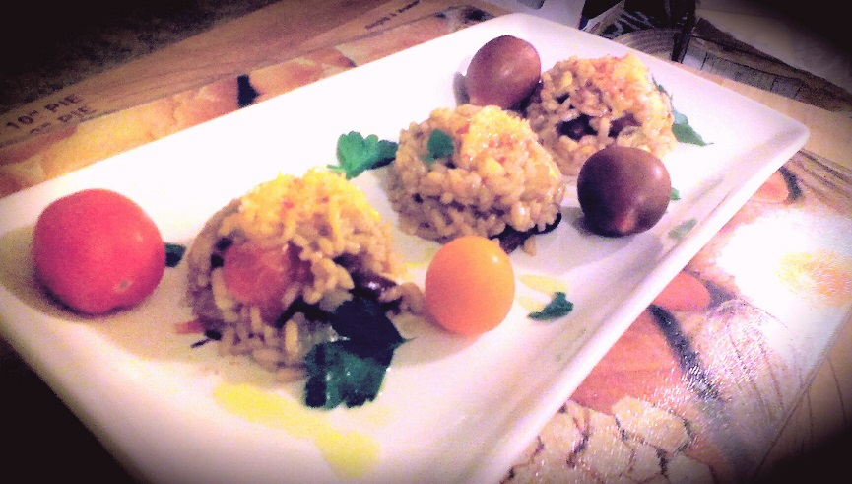

- In a large frying pan, heat the oil (about 2 tbsp) and butter on medium heat. Add the onions and celery and fry for 5-7 minutes stirring occasionally.

- Add the garlic and tomatoes and stir. Cook for 3 minutes and add the rice. Fry the rice stirring often (careful it doesn’t brown) for about 5 minutes.

- Add the beans, corn, parsley, chili powder, and stock. Give a few dashes of smoked paprika and, about a tablespoon of seat salt and a few cracks of black pepper. Bring to a boil on medium high heat.

- Reduce heat to medium low and cover. Cook for approximately 20 to 25 min (taste the rice and veg to ensure it is thoroughly cooked)

- Remove from heat and allow to cool for 5 minutes.

- Garnish with shredded marble or shredded sharp cheddar cheese.

