Panzanella Salad
Grocery List
- ½ Loaf Stale Crusty Bread, cut into cubes
- ¾ English Cucumber, seeded and sliced
- 1 Roma Tomato, halved and sliced
- 10-15 Grape Tomatoes
- ½ Red Onion, diced
- Fresh Parsley
- Dried Basil
- Salt / Pepper
- ½ Lemon, zested and juiced

- ¼ C Olive Oil
- 2 Tbsp red Wine Vinegar
- Salt / Pepper

Prep Time: 15 Min
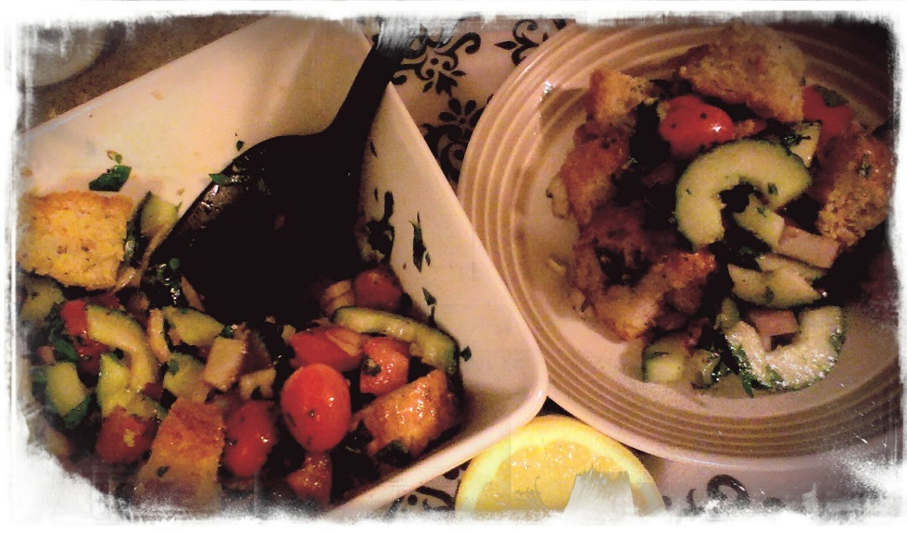
- In a large mixing bowl, combine the cucumbers, onions, and tomatoes.

- In a separate bowl, mix together the oil, red wine vinegar, Tsp of Salt and a couple cracks of Black Pepper. Stir and set aside.

- Add the cubes of crusty bread to the vegetable mixture. Add in a bunch of fresh parsley chopped, about a tsp of dried basil, and a pinch of salt / pepper.

- Zest your lemon over the salad and squeeze the juice over the entire bowl.

- Pour your dressing over the salad and gently stir to combine all ingredients.

- Serve immediately. If you make a bit too much it is still wonderful the next day however the bread may be a bit soggy in some places.

