Pasta Primavera
Grocery List
- 2 ¾ C uncooked Gemelli Pasta

- ¼ C Unsalted Butter
- 1 Shallot, diced
- 2 cloves Garlic, chopped
- ¼ C Red Bell Pepper, diced
- 1 C Broccoli Florets, roughly chopped
- 1/3 C Baby Carrots, sliced

- 2 ½ Tbsp. AP Flour
- 1 ½ C 2 % Milk (+)
- 2 Tbsp. Heavy Cream (+)
- 3 Laughing Cow White Cheddar slices
*1 – 2 Tbsp. Cream Cheese will also work
- ¼ Tsp. ground White Pepper
- ¼ Tsp. Black Pepper
- ¼ Tsp. dried Basil
- 1 Tbsp. Parmesan, grated
- 2 Tbsp. fresh Parsley, chopped
- Sea Salt

Prep Time: 10 Min
Cook Time: 25 – 30 Min
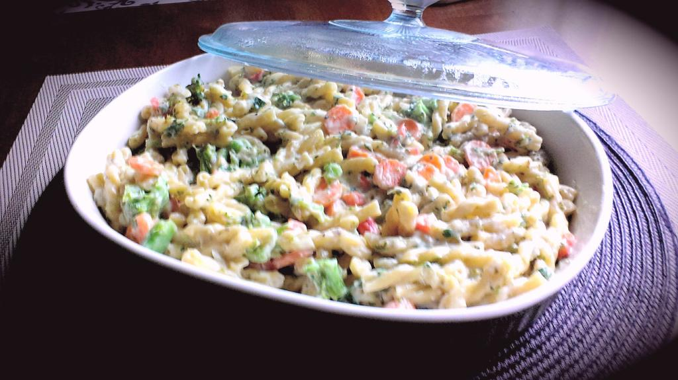
- Fill a large sauce ¾ full with cold water and bring to a boil on high heat. Season liberally with sea salt and add the pasta. Cook to Al Dente according to package directions. Strain and set aside.

- Using the same pan, melt the butter over medium heat. Add the garlic and shallot, cook 3 minutes stirring often.

- Stir in the broccoli, carrot, and pepper. Season with a pinch of sea salt. Cover and cook 5 minutes stirring a couple times.

- Stir in the flour and reduce heat to medium low. Continue stirring to prevent the flour from burning / browning. Cook 3 minutes before stirring in the milk and heavy cream.

**I put a (+) next to the milk and cream because depending on the amount of sauce / thickness you desire. If your sauce is too thick, add a little more milk slowly stirring it until the thickness is where you would like it.

- Increase heat to medium and bring to a boil stirring often. Stir in White Cheddar cream slices. Reduce heat to medium low and simmer 5 minutes stirring often to prevent sticking and burning.

- Add the parsley, dried basil, white and black pepper, parmesan, and a pinch of sea salt. Stir in the pasta in 2 or 3 batches to evenly coat everything. Taste and adjust salt / pepper if necessary.

- Transfer to a serving bowl and sprinkle with grated Parmesan.

