Simple Pesto
Prep Time: 5 Min
Cook Time: - - -
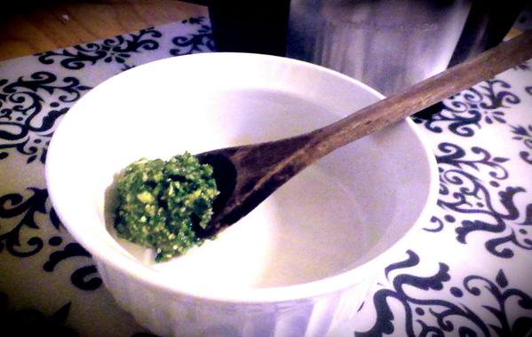
Grocery List
- 3 Cups Fresh Basil Leaves
- 6 Cloves Garlic
- ½ C Pine Nuts
- ¼ C Parmesan cheese, grated
- ½ C Extra Virgin Olive Oil
- Cracked Sea Salt

- Combine all ingredients in your food processor. Pulse until thoroughly blended. Add in your desired amount of salt (I used about a tea spoon) and pulse a few more times manually to combine the salt.

