Poor Man’s Beef”Less” Wellington
Grocery List
- 340g pkg. YVES VEGGIE GROUND ROUND
- 2 Pillsbury Crescent Rolls
- 10 slices YVES VEGGIE HAM
- 1 ½ C Mozzarella Cheese, shredded
- ½ Yellow Onion, sliced
- 1/3 C fresh Parsley, chopped
- AP Flour
- Sea Salt / Black Pepper

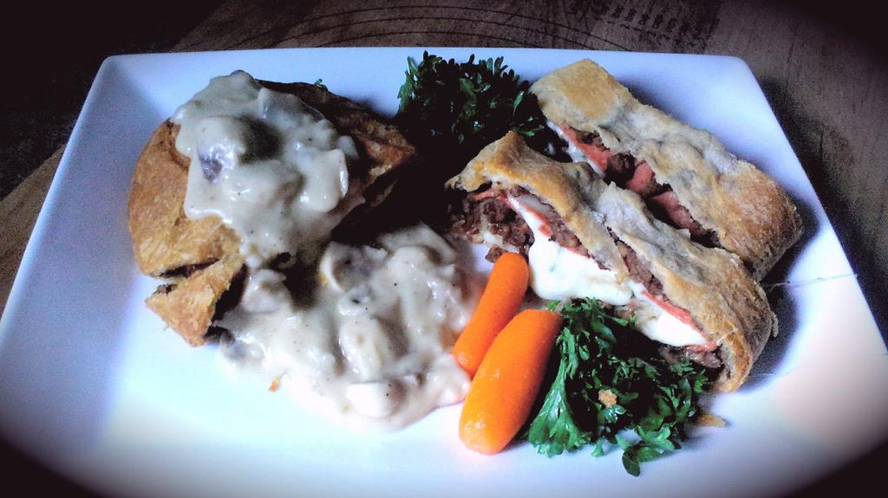
Prep Time: 12 Min
Cook Time: 45 – 50 Min

- Preheat oven to 350 F

- Lay out your puff pastry dough (x2) on a lightly floured surface and gently roll them out.

- (YOU WILL DO THIS STEP FOR EACH PASTRY ROLL) Start by spooning half the crumbled veggie ground through the middle of the pastry leaving about a fingertips length around all sides. Season with sea salt and black pepper. Next, lay half the sliced onions across the ground round. Follow with 5 slices of veggie ham, ½ the shredded mozzarella, and ½ the chopped parsley. Starting from the bottom, roll the pastry slowly until it is fully rolled with the seam folded side on the bottom.

- Pinch both ends of the roll to seal it and look for splits in the roll and pinch them together as well. Lay on a baking sheet side by side and sprinkle each roll with a pinch of sea salt and black pepper.

- Loosely cover with tinfoil and bake for 25 minutes before removing the foil and baking another 20 -25 minutes. Remove and transfer to wire rack to cool briefly. (2 or 3 Min)

- For service, cut into slices and dredge in your favourite gravy and chopped, fresh parsley.

