Prepping Leeks

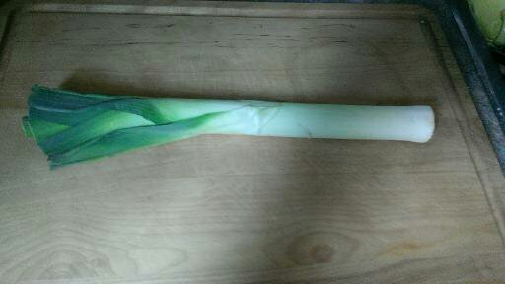
- This is a leek. Looks similar to a scallion (green onion) but is much larger and unlike the green onion, you are only going to use the white and light green parts of the Leek.

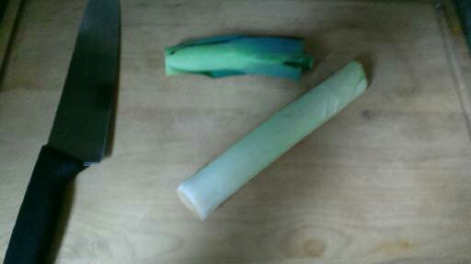
- Cut off the darker green portion of the leek. You should now be left with only the white and light green portions.

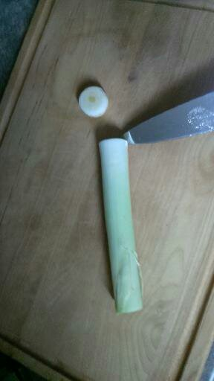
- Cut off the root end of the leek.

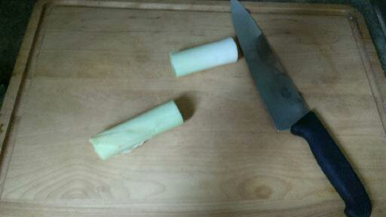
- Cut the leek in half width wise, leaving you with two smaller, more manageable pieces.

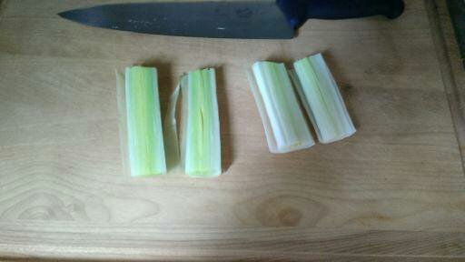
- Slice the leeks in half lengthwise, you should now see several layers within the leek.

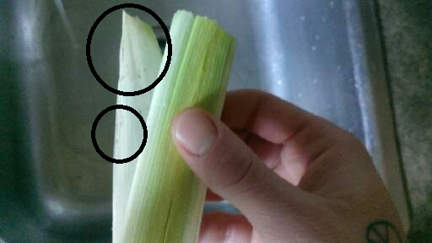
- NOTE THIS: Leeks are notoriously dirty, upon pulling apart each layer there will likely be dirt hiding. Be very thorough when washing the leeks to avoid and dirty remnants.

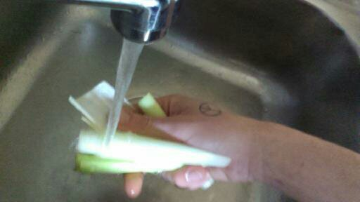
- However time consuming, wash between each layer of the leek and toss into a strainer and hold until ready to chop.

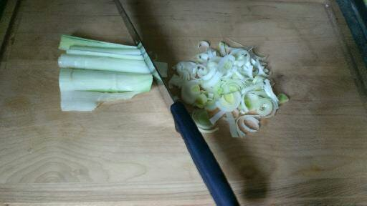
- Now you may begin chopping the leeks starting from one end and working your way down. Keep the open layers side facing down to make the leeks easier to chop. Less slipping around.

Now get to souping !
HAPPY VEG

