Ricotta Manicotti with a sauce of medley tomatoes and baked to perfection.
Grocery List
- 454g Light Ricotta
- ¼ C shredded Mozzarella
- 1 large Basil leaf, roughly chopped
- ¼ C fresh Parsley, roughly chopped
- 2 cloves Garlic, pressed
- ½ Tsp. Black Pepper
- 1 Tsp. Sea Salt

- 341g package Medley Tomatoes
- ¼ C EV Olive Oil
- 2 Tbsp. Unsalted Butter + ½ Tbsp.
- 1 large Yellow Onion, diced
- 3 cloves Garlic, minced
- 1 Basil leaf, rolled and sliced
- Approx. ½ C fresh Parsley, roughly chopped
- Pinch Red Pepper flakes
- ¼ Tsp. Sugar

- 8 Manicotti Noodles

Prep Time: 25 Min
Cook Time: 45 Min
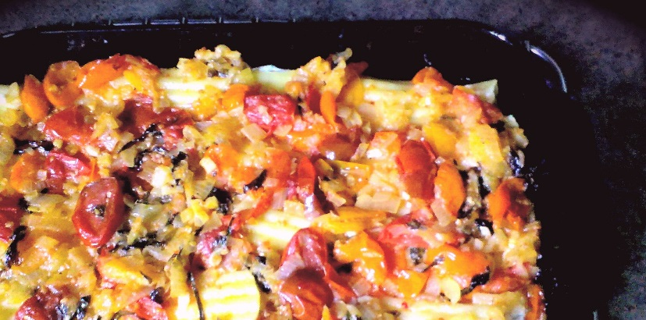
- In a small mixing bowl, combine the light ricotta, mozzarella, parsley and basil, salt and pepper, and pressed garlic. Stir together to combine, cover, and refrigerate until ready to use.

- Bring a large sauce pan filled with approximately 4L of cold, salted water to a boil on high heat. Add the manicotti and cook until soft but still firm enough to handle and fill. (About 12 minutes) Strain (reserve boiling pasta water) and rinse under cold water. Set aside.

- Preheat oven to 375 F

- In a large frying pan, bring to temperature on medium and add the oil and unsalted butter. Add in the onions and 2 pinches of sea salt. Stir and fry until translucent (about 5 minutes). Sprinkle in the minced garlic and red pepper flakes. Stir and fry another 2 or 3 minutes.

- Next, add in the tomatoes and a generous pinch of sea salt, fry for 3 or 4 minutes stirring often. Add in 2 ladles of the boiling pasta water, sugar, the basil and parsley, ½ Tbsp. unsalted Butter, and a pinch each of salt and black pepper. Cover and continue cooking on medium heat for about 15 minutes. (Check the sauce often and add in more pasta water to get the sauce to the consistency you desire)

- Lightly oil an 11 x 7 baking dish.

- Fill the manicotti using a teaspoon to scrape the mixture into the openings and the rounded side to press it in. Place in the baking dish.

OR

Slice the manicotti length wise and open up. Place the mixture through the middle and roll the manicotti around the filling. Place in the baking dish open side down.

- Pour your sauce evenly over the dish making sure to cover every corner with the medley sauce. Cover with tinfoil and bake for 15 minutes. Remove cover and bake another 5 minutes until nice and bubbly.

- Serve sprinkled with grated parmesan and fresh parsley.

