Roasted Tomatoes
Grocery List
- 16-18 Campari Tomatoes
- ½ C EVOO
- ½ Yellow Onion, sliced
- 2 cloves Garlic, roughly chopped
- 6- 8 fresh Basil leaves
- 3 Stems Parsley, including leaves
- Sea Salt / Black Pepper

- Grated Parmesan

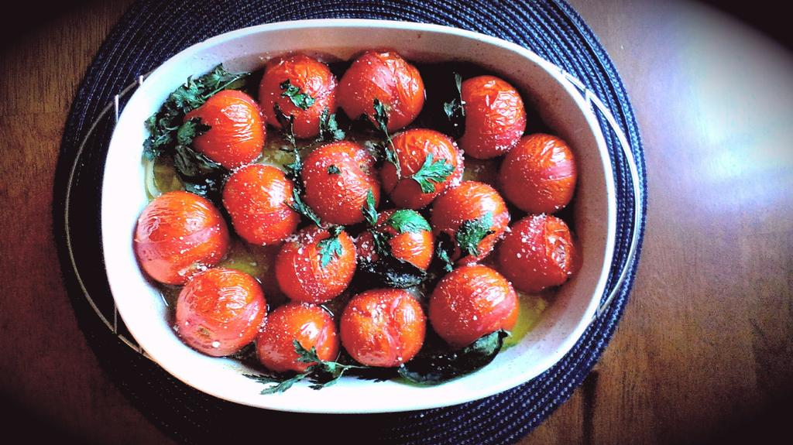
Prep Time: 2 Min
Cook Time: 25 – 35 Minutes

- Wash the tomatoes and pat them dry with a paper towel. Remove the stems and set them aside.

- Preheat the oven to 375 F

- In a 1 ½ qt. baking dish, pour half the EVOO in. Line the onions along the bottom of the dish and sprinkle the garlic in.

- Line the tomatoes in the dish and press the fresh herbs in between the tomatoes throughout the dish. Pour the rest of the oil over the tomatoes and season liberally with sea salt and black pepper.

- Bake 25 – 35 minutes until tomatoes are wrinkled and bursting.

- Serve with a sprinkle of grated parmesan cheese.

