Salsa Verde
Grocery List
- 400ml can Tomatillo, drained
- 1 Tbsp. fresh Cilantro
- 1 Tbsp. fresh Parsley
- 1 Jalapeno, seeded
- ½ Yellow Onion, roughly chopped
- 2 Tbsp. Jalapeno Hot Sauce
- 2 Tbsp. EVOO
- Sea Salt / Black Pepper

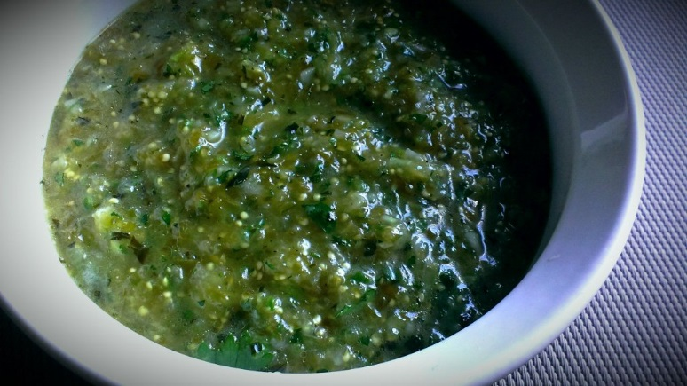
Prep Time: 5 Min

- Combine all ingredients in food processor. Season with sea salt / black pepper to taste. Pulse a few times before finishing on puree until thoroughly blended.

