Sloppy Jon’s
Grocery List
- ¼ C EVOO
- 1 clove Garlic, chopped
- ½ Green Pepper, diced (about ¾ C)
- 1 Yellow Onion, diced (about 1 cup)
- 10 Grape Tomatoes, halved
- 1 C Tomato Sauce
- 1 Tbsp. Tomato Paste
- 320 G pkg. YVES Veggie Crumble
- ¼ C Black Beans
- 1 Tsp. Brown Sugar
- Sea Salt / Black Pepper
- Red Pepper Flakes

- 12 – 15 Mini Italian Rolls
- 12 – 15 slices Marble Cheddar from the brick.
- Green Onion (garnish)

Prep Time: 10 Min
Cook Time: 25 – 28 Min
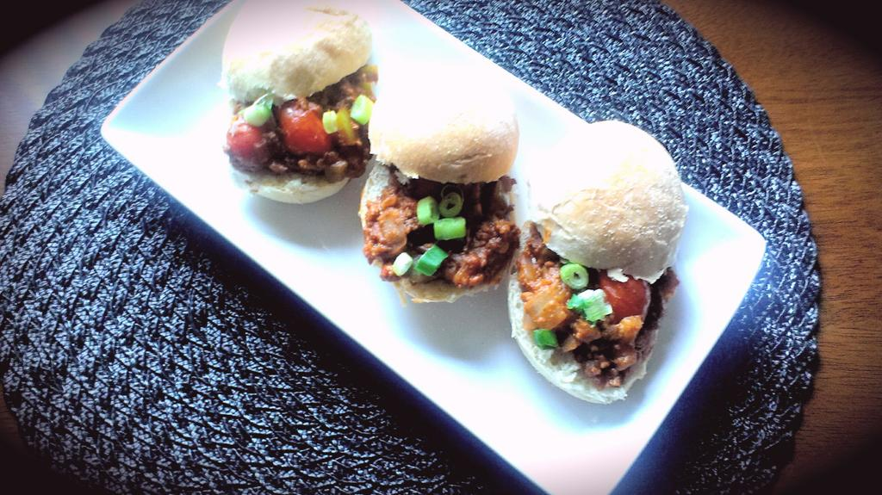
- Bring a large frying pan to temperature just below medium. Pour in and heat up the oil before adding in the minced garlic. Stir often for 2 minutes.

- Add the green pepper and onions and a good pinch of sea salt and black pepper. Fry for about 6 - 7 minutes stirring often until onions are a bit translucent. Stir in a pinch of red pepper flakes and allow a minute to combine.

- Add the halved tomatoes, black beans, and another pinch of sea salt / black pepper. Continue cooking another 3 minutes before stirring in the tomato sauce, paste, brown sugar, and a pinch of sea salt. Bring to a light boil before stirring in the YVES veggie crumble and reducing to medium low.

- Cook for 10 Minutes on medium low, covered.

- For service, slice the buns and lay the bottom with a slice of marble cheddar. Each bun will take about a Tbsp. and a half of the mixture. Sprinkle with a few slices of green onion and enjoy.

