Southwestern Pinto Beans (quick)
Grocery List
- 528 ml can Pinto Beans packed in water with onion and peppers
- 2 Tbsp. Unsalted Butter
- 1 Red Bell Pepper, diced
- 1 Yellow Bell Pepper, diced
- 1 Jalapeno, seeded and diced
- 1 small Red Onion, diced
- 2 Green Onions, sliced
- 2 cloves Garlic, chopped
- Sea Salt / Black Pepper

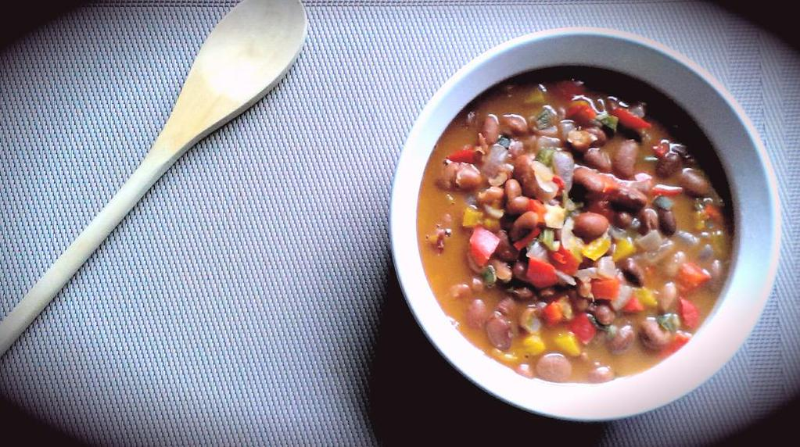
Prep Time: 10 Min
Cook Time: 30 + Min

- In a medium sized sauce pan, melt the butter on medium. Add the garlic and fry 2 – 3 minutes stirring often.

- Stir in all the rest of the diced veg and season with a good pinch of sea salt / black pepper. Continue frying another 5 minutes stirring often.

- Pour in the can of beans including the liquid. Stir and allow the beans to come to a boil. Reduce heat to low and cover. Simmer at least 20 minutes (until all veg are tender) before serving. The longer they cook the better!

- Taste and adjust salt and pepper if necessary.

