Pesto “Bruschetta”
Prep Time: 10 Min
Cook Time: 10-12 Min
Grocery List
- 1 Large French Crusty Bread
- 1 Cup fresh Baby Spinach
- 10-15 Medley Tomatoes
**Some halved, some quartered, depending on size
- ½ Red Onion, diced
- 1 ½ Cup prepared Pesto
- Olive Oil
- Sea Salt

OPTIONAL
- Shredded Parmesan
- Sundried Tomatoes

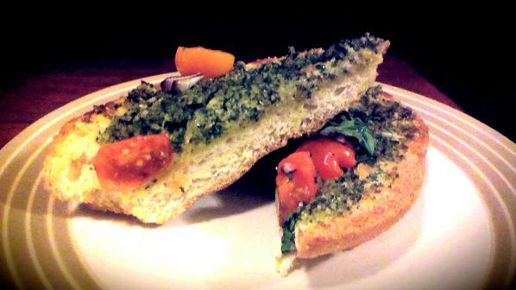

- Preheat the oven to 450 on Broil.

- Halve the Loaf lengthwise so you are working with two equal sized pieces.

- Drizzle olive oil over the open faced parts of the bread. Split the pesto evenly between both halves. Using a wooden spoon, smear the pesto along all the outside edges and work your way into the middle.

- Next, lay the spinach, tomatoes, and onions. Drizzle again with olive oil from one end to the other.
**Medley tomatoes are any combination of Grape Tomatoes, Golden Grape Tomatoes, Baby Roma Tomatoes, Zebrinos, Cherry or Yellow Cherry Tomatoes. They add a lovely colour and vibrancy to a tomato dish!
- Broil on bottom oven rack for 10 – 12 Minutes (Watch for the outside edges to stay brown. Remove before ANY blackening happens.)

- Remove and allow to cool for a minute or two. Crack some sea salt over both halves before serving. Slice and serve.

