Spinach Pesto Pasta Bake
Grocery List
- 1/3 C EV Olive Oil + some for drizzling
- 1 Yellow Onion, diced
- 1 C diced red onion / yellow bell pepper combined
- 4 cloves Garlic, chopped
- 1/3 C fresh Parsley
- 3 Tbsp. Happy Veg Spinach Pesto (or any fresh or pre-packaged pesto)
- 796 ml can diced Tomatoes, blended / pureed
- 1 ½ C shredded Mozzarella
- 3 Tbsp grated Parmesan
- 2 Tbsp. Italian Breadcrumbs
- Sea Salt / Black Pepper
- 450 g Tortiglioni or any ridged noodle

A combination of spinach pesto and tomato sauce cooked together with onions, bell pepper, and parsley and baked layered with noodles, parmesan and mozzarella cheese.
Prep Time: 20 Min
Cook Time: 1hr 25 Min
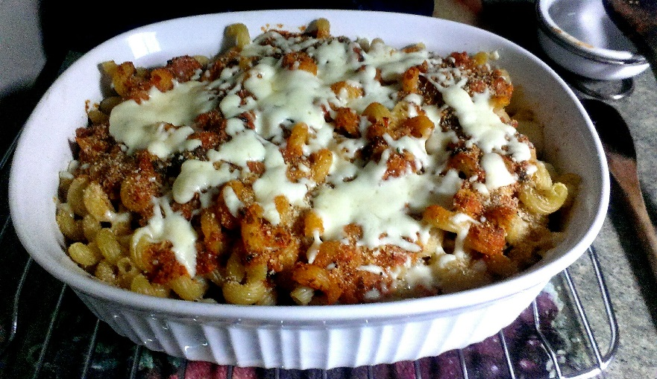

- In a large saucepan, boil your choice of ridged noodle to al dente following package directions. Strain and set aside.

- Bring a large frying pan to temperature on medium. Pour in the olive oil and add in the diced red and yellow onions and the yellow pepper. Give a pinch or two of sea salt and fry together for about 5 minutes stirring often.
Make a little circular area in the center of the pan and drizzle a tiny bit of olive oil. Add the chopped garlic and allow to fry for 2 minutes before stirring everything together and adding a pinch of sea salt and black pepper. Fry another 2 minutes.

- Stir in the pesto and fry together for 2 or 3 minutes before adding the blended tomatoes and parsley. Bring to a boil and cover reducing heat to medium low. Cook 20 minutes at least until ready to use, taste and adjust seasoning.
***To thicken the sauce, remove the lid for the last 5 minutes and it will thicken up.

- Preheat oven to 350 F

- In a lightly oiled 2 ½ qt baking dish, lay out a layer of noodles covering the bottom. Drizzle the layer with olive oil and sprinkle 1/3 the mozzarella and 1 Tbsp. parmesan. Ladle 2 scoops of sauce evenly over the layer.

- Repeat the last step 2x except on the top layer do not sprinkle the mozzarella. Cover and bake for 20 minutes

- Sprinkle the bread crumbs and remaining mozzarella evenly over the dish. Bake uncovered another 10 – 15 minutes.

- Cool and serve. Garnish with fresh parsley and parmesan cheese.

**Great with garlic toast and a salad

