Stuffed Shells
Grocery List
- 18 – 20 Pasta Shells

- ¼ C EVOO
- 1 Yellow Onion, diced
- 1 stalk Celery, diced
- ¼ C Carrot, diced (1 medium carrot)
- 4 cloves Garlic, sliced
- 796ml can Whole Tomatoes
- 4 – 6 fresh Basil leaves
- 3 stalks Parsley including leaves
- ¼ Tsp. Sugar
- Sea Salt / Black Pepper

- 300g tub Light Ricotta Cheese
- 1 Tbsp. Cream Cheese
- ¼ Yellow Onion, minced
- ¾ C shredded Mozzarella
- 1 Tbsp. fresh Basil, chopped (3 – 6 Basil leaves depending on size)
- 2 Tbsp. fresh Parsley, chopped
- Sea Salt / Black Pepper

- ¾ C shredded Mozzarella
- Parsley / Basil garnish

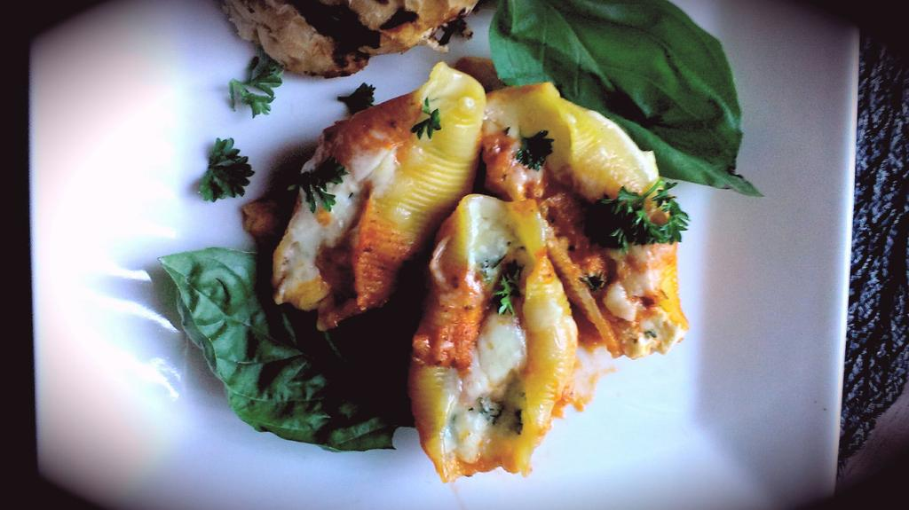
Luscious tomato sauce and mozzarella cheese baked over ricotta and herb stuffed pasta shells.
Prep Time: 30 Min
Cook Time: 1 Hr

- Bring a medium sized sauce pan to temperature on just below medium. Pour in the EVOO and allow a minute to heat through before adding the garlic. Stir often for 3 minutes before adding the diced onion, celery, and carrot. Give a pinch of sea salt / black pepper and cover. Cook 5 minutes stirring occasionally.
Pour in the canned tomato, sugar, and a pinch of both sea salt and black pepper. Once the sauce boils, reduce to medium low, cover, and simmer 15 minutes until all vegetables are tender. Add the basil and parsley within the last 5 minutes of cooking. Blend using an Immersion Blender, taste and adjust salt and pepper if needed. Leave on low heat.

Complete the next 2 steps while the pasta sauce is cooking to maximize time efficiency

- Bring a large pot of cold water to a boil on medium high heat. Salt liberally and add shells. Cook to Al Dente, strain, and rinse with cold water (or a prepared ice bath) to stop the pasta from overcooking.

- In a small mixing bowl, combine the ingredients for the ricotta stuffing including a good pinch of salt / pepper and mix with a fork to combine.

- Preheat oven to 375 F

- Fill a 3 qt. baking dish ¼ of the way full with the blended sauce. Use a teaspoon to spoon the mixture into the shells and line them in one layer across the dish. Drizzle more sauce over the shells and sprinkle the remaining mozzarella over the dish. Cover and bake 15 minutes. Remove cover and bake another 10 – 15 Min.

- Garnish with fresh parsley and basil.

