Tex Mex Lasagne
Grocery List
- 20 Lasagne Noodles

- ¼ C EVOO
- 3 cloves Garlic, crushed & chopped
- Red Onion, diced
- 2 Green Onions, sliced
- 1 Jalapeno, seeded & diced
- 2 C Bell Pepper, chopped (Red, Yellow, Green, Orange, mix it up!)
- 598ml can San Marzano Tomatoes
- 2 Tsp. fresh Cilantro, chopped
- ½ Tsp. Red Pepper Flakes
- ¼ Tsp. Sugar
- Sea Salt / Black Pepper

- 2 C Tex Mex cheese, shredded
- 3 C Ricotta Cheese, room temperature

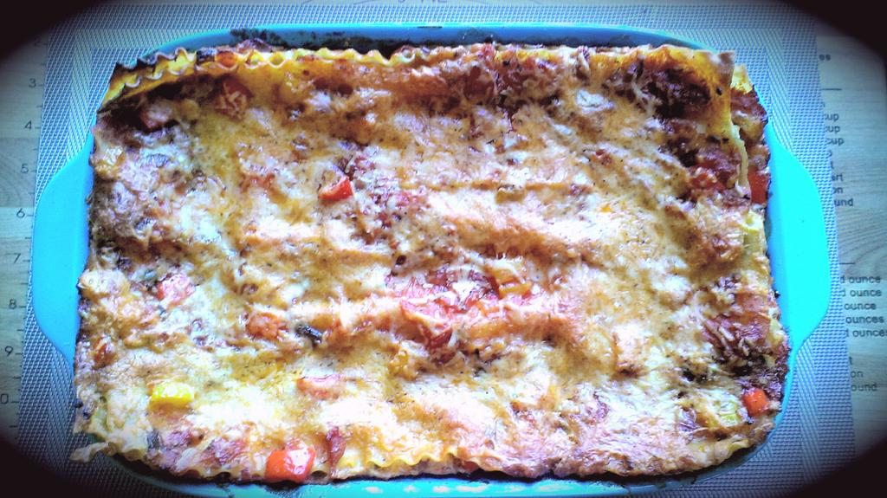
Prep Time: 15 Min
Cook Time: 60 – 65 Min

- Bring a large sauce pot filled with cold water to a boil on medium high heat. Season liberally with sea salt and add the lasagne noodles. Cook to Al Dente according to package, strain and run under cold water to prevent over cooking.

**Maximize time by starting the sauce while the noodles are cooking.

- In a medium sauce pan, bring to temperature on medium and add the EVOO. Allow a minute to heat and add the garlic in stirring often for 3 minutes. Add the red / green onions, bell peppers, jalapeno and ¼ Tsp. red pepper flakes. Give a good pinch of sea salt and black pepper. Cover and cook 5 or 6 minutes stirring occasionally.

- Pour in the tomatoes and immediately use a masher to smash the tomatoes in the pot. Bring to a boil.

- Add in the cilantro, the other ¼. Tsp red pepper flakes, sugar, and a pinch of sea salt and black pepper. Reduce heat to medium low and simmer 15 minutes.

- Preheat oven to 350 F

- Transfer the sauce to a serving bowl. Have a station set up with your 2 ½ qt. Baking dish, bowl of sauce, and the shredded cheese / ricotta also on hand to begin building. Take the noodles from the strainer and line them on a plate.

**You only need 16 noodles to make the lasagne, 20 is to compensate for broken or unevenly cooked noodles.

- Start by ladling a scoop of sauce in the bottom of the dish and spread it around to coat the dish. Line 4 noodles lengthwise for the first layer. Split the Ricotta into 3 batches to make things easier and spoon the first batch onto the noodles. Use a spoon to spread the ricotta across the noodles entirely. Ladle more sauce on top of the ricotta mixture again, spreading it around and sprinkle with ¼ C of the shredded Tex Mex cheese. Repeat two more times.

- For the top, ladle the remaining sauce to coat the entire dish and sprinkle the remaining ¼ C Tex Mex cheese all over the dish.

- Bake uncovered 30 – 35 minutes until bubbly and delicious. Allow to cool 15 minutes before cutting into.

- Garnish with freshly sliced Green Onion and Cilantro.

