Tri-Colour Tomato Basil Penne
Prep Time: 20 Min
Grocery List
- 2 Cups Penne Pasta
- 2 Cups Multi Coloured Cocktail Tomatoes
- 1 Small Red Onion, diced
- 3 cloves Garlic, minced
- Fresh Parsley
- Fresh Basil – about 5 or 6 Leaves
- Sea Salt / Cracked Black Pepper
- ½ Tsp White Sugar
- 200g Bocconcini Cheese (I used Pearls but you can use the larger sized ones you will just have to slice them a bit smaller)
- Olive Oil
- ¼ C Unsalted Butter

Cook Time: 20-25 Min (approximately)

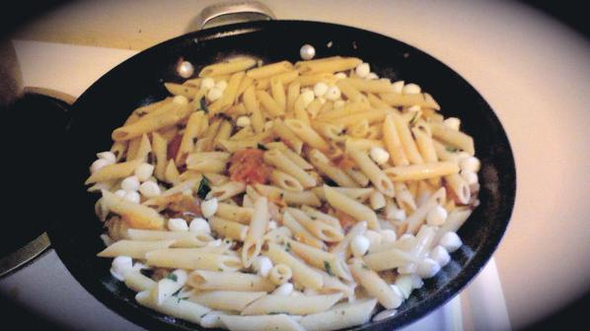
- On medium heat, melt the butter and add in a drizzle of olive oil. Add in the diced onions and a pinch of salt and fry for about 5 minutes stirring often.

- Add in the minced garlic and fry another 2 or 3 minutes.

- In a separate pan, boil your Penne until it is Al Dente (follow package instructions), remove from heat and strain. (reserve pasta water)

- Add in your tomatoes and a pinch of salt and put the lid on for about 5 minutes until a sauce begins to form on the bottom of the pan. Stir and continue cooking another 2 or 3 minutes.
***As the cocktail tomatoes come in various sizes, try to chop them to the same size. Larger ones you might want to quarter and the smaller ones you can simply cut in half.
- Toss in your cooked pasta, freshly chopped basil, about 2 Tbsp freshly chopped parsley, and approximately a ¼ C pasta water. Add in a few cracks of black pepper, the sugar, and a pinch or 2 of sea salt. Cover and allow to cook for another 6 or 7 minutes, stirring occasionally.

- Remove from heat and allow to cool about 5 minutes. Add in the bocconcini and serve right away. (The bocconcini MAY melt if the pasta is too hot however it still tastes fantastic! Larger pieces of the bocconcini will hold together a bit better.)

