Tomato Basil Pasta Stuffed Pepper
Grocery List
- 4 Bell Peppers, cored, seeded, and membrane removed
- 4 C cooked Macaroni Noodles
- 2 C Medley Tomatoes, halved
- 2 Roma Tomatoes, halved lengthwise and sliced thick
- 1 ½ Yellow Onions, diced
- 5 cloves Garlic, chopped
- 1 Zucchini, halved lengthwise and sliced
- 10 Basil Leaves +2 Garnish
- ¼ C chopped Fresh Parsley +6 or 7 stalks.
- ¾ C low sodium Vegetable Stock
- 1 Tsp. Tomato Paste
- 4 Thick Slices Mozzarella / Marble + ¼ C grated for garnish
- ¼ C EVOO
- ¼ C Pepper Water
- Sea Salt / Black Pepper
- Pinch Sugar

Prep Time: 15 – 20 Min
Cook Time: 50 Min +
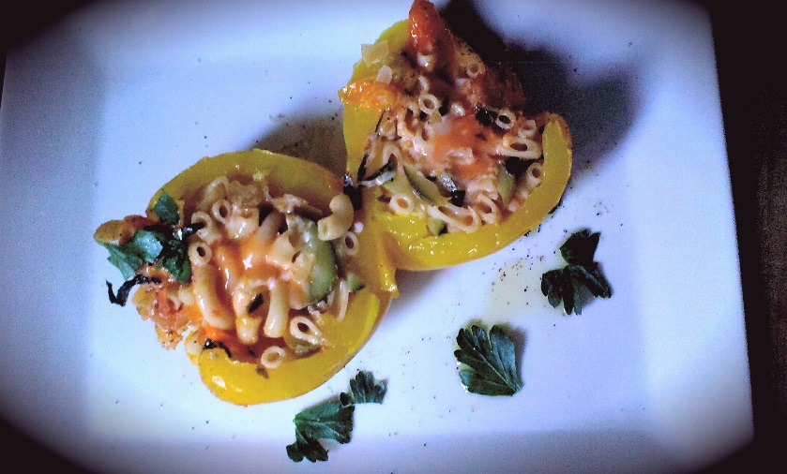
- Bring 6 C cold, generously salted water to a boil in a large sauce pan on high. Add the 4 Peppers and cover with the lid tilted for 5 Minutes. Remove and strain reserving ¼ C of the pepper water.

- In a large frying pan, heat to just below medium and add the ¼ C EVOO. Next, add the onions and a good pinch of sea salt / pepper. Fry 3 or 4 minutes and stir in the garlic. Fry another 3 minutes stirring often to avoid heavy browning.

- Add the tomatoes (medley, roma) and another pinch of sea salt. Allow a couple minutes of cooking and then add in the zucchini. Fry another 2 or 3 minutes stirring often.

- Stir in the tomato paste and pour in the vegetable stock and pepper water. Stir in your freshly chopped basil / parsley, ½ Tsp. Sea Salt / ¼ Tsp. Black Pepper and the pinch of sugar. Bring to a boil on medium, reduce heat to medium low and cover. Cook 15 minutes until tomatoes are cooked down. Taste and adjust salt / pepper if necessary.

- Stir the pasta into the sauce and remove from the heat.

- Preheat oven to 375 F

- Fill a 1 ½ qt baking dish with ¼ C water, 2 Tbsp. EVOO, and the 6 stalks of parsley (stem and leaves)

- Using a ladle, scoop the pasta mixture into the pepper using the closed side to press the pasta in. Arrange the peppers in the dish. Take the sticks of cheese and slip them down through the centre of each of the peppers. Sprinkle with sea salt and black pepper, 2 chopped basil leaves, and the ¼ C shredded cheese.

- Bake covered for 15 Minutes and uncovered for 10 - 13 Minutes.

