Tortsagne
Grocery List
- 8 large Flour Tortillas
- 2 x 540ml cans Black Beans, drained and rinsed
- 2 Tbsp. unsalted Butter
- 1 Tbsp. EVOO
- 1 C. diced Red Onion
- 1 Jalapeno, seeded and diced
- 2 cloves Garlic, chopped
- 1 ½ C shredded Monterey Jack cheese (reserve ½ C for top)
- 1 C shredded Jalapeno White Cheddar cheese
(Any spiced cheese will do or use regular cheddar and amp up the fresh jalapeno)
- 1 Roma Tomato, seeded and diced
- 1 Tbsp. chopped fresh Cilantro
- ½ the zest of 1 Lime.
- 1 ½ C prepared Guacamole

- 2 Green Onions, sliced
- Light Sour Cream (optional)
- Hot Sauce (optional)
- Tomatillo Salsa (optional)

Layers of scratch made refried beans, guacamole, and black beans smothered in cheese
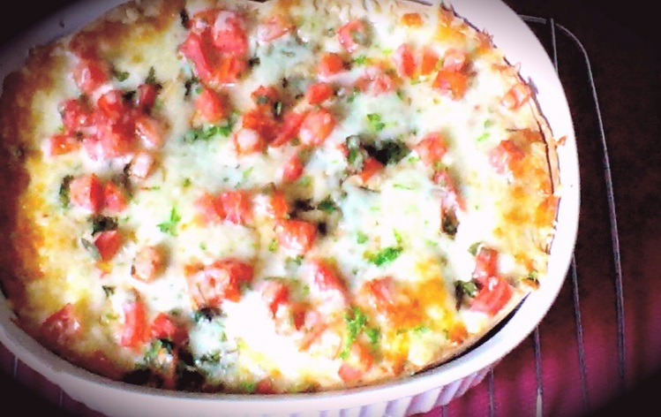
Prep Time: 30 Min
Cook Time: 53 Min +
- - 6 Large Portions

- Start a medium saucepan on medium heat. Pour in the EVOO and stir in the red onion and jalapeno. Season with a pinch of sea salt / black pepper and fry 4 minutes stirring often to avoid browning.

- Make a circle in the center of the pan and pour in about a tsp. of EVOO and add the garlic to the circle. Give it a minute to cook before stirring into the other vegetables. Fry another 2 minutes and pour in 1 can of the drained, rinsed black beans. Season with about a tsp. sea salt and ½ Tsp. black pepper. Cover and give 2 or 3 minutes before stirring and reducing heat to medium low for 10minutes.

- Stir in the 2 generous Tbsp. of unsalted butter and once melted, use a potato masher to mash the beans for the first time. Stir and cover for 3 minutes.

- Mash the beans for the second time until they are mostly mashed. (A few semi whole beans is no big deal) Reduce heat to low and leave covered until ready to use.

- If you have not prepared the Guacamole in advance, prepare it now. (Refer to my CHUNKY GUACAMOLE recipe or use your own special recipe)

- Preheat oven to 375 F

- In a 1 ½ qt. baking dish, drizzle with olive oil to coat the bottom and sides and lay down the first 2 tortillas folding excess up the side of the dish. Transfer the refried beans to the baking dish spreading evenly to form the first layer. Sprinkle with ¼ of the shredded cheese.

- Layer 2 more tortillas and add in the guacamole. Spread evenly once again and sprinkle with ¼ of the shredded cheese. Layer two more tortillas and now layer the 2nd can of drained, rinsed black beans. Give a good pinch of sea salt to the bean layer. Sprinkle with another ¼ of the shredded cheeses and top with the final two tortillas. Sprinkle the diced tomatoes and cilantro across the dish and top with the remainder of the shredded cheese (should be a ½ C).

- Cover and bake 15 Min before removing the lid and baking another 15 – 20 Min until cheese is browning and bubbly! Once removed from oven, garnish with the green onions and lime zest and allow 10 minutes to cool before slicing.

- Condiments for the dish should include

- Tomatillo Salsa
- Hot Sauce
- Pickled Jalapeno
- Sour Cream

