Warm Medley Potato Salad
Grocery List
- 683g (approx. 2 ½ C) Medley Mini Potatoes – Red, White, Purple
- EVOO
- Sea Salt / Black Pepper

- ¼ C EVOO
- 2 Tbsp. Balsamic Vinegar
- 1 Tbsp. fresh Rosemary, finely chopped
- ½ Tsp. fresh Thyme
- ¼ Tsp. dried Basil
- ½ Tsp. dried Parsley
- ¼ Tsp. Black Pepper
- ¼ Tsp. Sea Salt

- ¼ C fresh Parsley
- ½ Red Onion, sliced & quartered

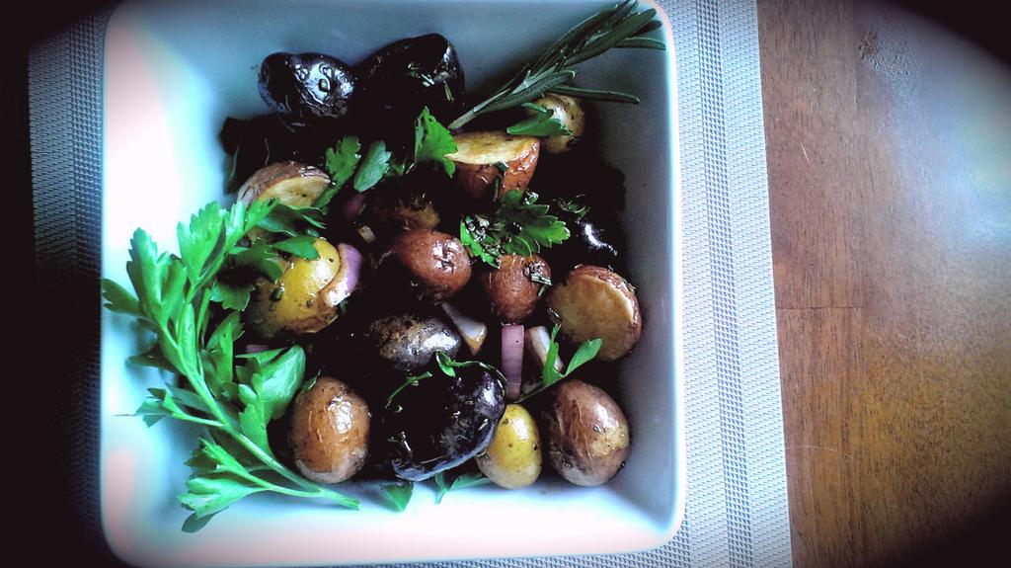
Prep Time: 10 Min
Cook Time: 35 – 40 Min

- Preheat oven 400 F

- Wash and pat dry mini potatoes. Halve any larger sized potatoes to ensure even cooking.

- Put the potatoes in a shallow baking dish and give a generous drizzle of EVOO and also a generous pinch of sea salt and black pepper.

- Bake for 35 – 40 Min. Start piercing the biggest potato with a fork after 30 Min, if the fork easily slides through, the potatoes are finished.

- In a medium sized mixing bowl, combine ¼ C EVOO, vinegar, and all herbs and seasonings. Whisk together to combine.

- Transfer hot potatoes to bowl with vinaigrette and toss to coat all potatoes. Stir in the onion and fresh parsley. Transfer to a serving bowl and serve warm.

- Garnish with fresh Parsley or Rosemary on the stem.

