Zucchini & Corn Chili Cups
Grocery List
- 6 Old El Paso Tortilla Bowls

- 2 Tbsp. EVOO
- 2 Tbsp. Unsalted Butter
- 2 Zucchinis, halved lengthwise and sliced (3 cups approximately)
- ½ Red Onion, diced
- ½ Yellow Bell Pepper, chopped
- 2 Green Onions, sliced
- 2 cloves Garlic, chopped
- 1 Russet Potato, cubed
- 1 Jalapeno, seeded and diced
- ½ C frozen Sweet Corn

- ¼ C low sodium Vegetable Stock
- 1 ½ Tbsp. Cilantro, chopped
- ½ Tsp. Red Pepper Flakes
- ½ Tbsp. Smoked Paprika
- ½ Tsp. Garlic Powder
- 1 ½ Tbsp. Mexican Hot Sauce
- Sea Salt / Black Pepper

- ½ C Monterey Jack Cheese, shredded
- ¼ C Marble Cheddar, shredded

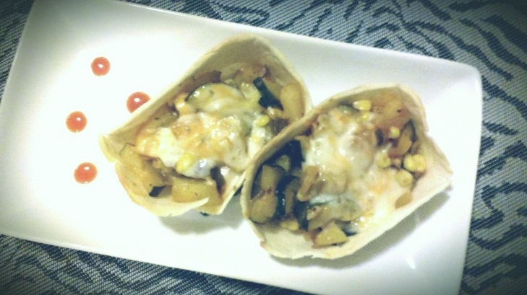
Prep Time: 15 Min
Cook Time: 45 Min

- Bring a medium sized sauce pot filled with cold water to a boil on medium high heat. Add a generous pinch of sea salt and the cubed potato. Boil partly covered for 5 minutes, strain and set the potatoes aside.

- In a large frying pan, bring to temperature on medium and melt the butter and EVOO together. Add the red and green onion, yellow bell pepper, jalapeno pepper, and a good pinch of sea salt. Cook 5 minutes stirring often.

- Stir in diced potato, garlic, and red pepper flake and continue frying another 3 or 4 minutes. Stir in the zucchini and another pinch of sea salt and continue frying another 3 minutes.

- Add the vegetable stock, hot sauce, cilantro, paprika, garlic powder, ¼ Tsp. Black Pepper, and a pinch of sea salt. Cook covered over medium heat 10 - 13 minutes stirring often.

- Preheat oven to 375 F

- Line a baking sheet with tinfoil and line tortilla cups on the sheet. Bake 3 – 4 minutes and remove.

- Scoop the zucchini mixture into the 6 cups and split the shredded cheese evenly between them for the tops. Bake another 5 – 7 Minutes until edges of tortilla bowls are starting to brown and cheese is melty.

