Basic Hummus
Grocery List
- 1 540ml can Chick Peas
- 2 Tbsp Tahini
- 1/3 C E.V. Olive Oil
- 2 cloves Garlic, crushed
- ½ Lemon, zest and juice
- Sea salt

- Chick Peas
- Chopped Fresh Parsley
- Olive Oil
- Paprika

Prep Time: 12-15 Min
Cook Time: - - -
Serves 3-4
NOTE: FOOD PROCESSOR
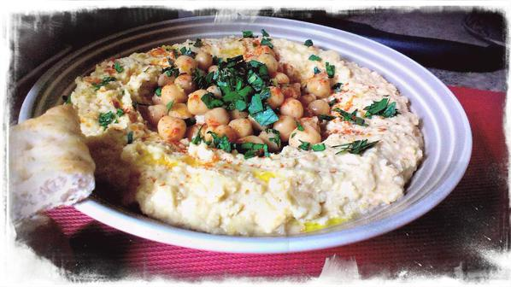

- Empty the can of chick peas into a strainer reserving 2 Tbsp of the liquid. Rinse the chickpeas in cool water.

- Combine the chickpeas, garlic, tahini, lemon zest and juice, and turn the processor on. Slowly pour the olive oil into the processor while it is blending. Remove the lid and add 4 cracks of sea salt.

- Pulse and taste. Adjust the salt.

- Transfer to a serving bowl. Using a spoon, hollow out the middle of the hummus creating a little “gravy” bowl. Top with chick peas, freshly chopped parsley, a drizzle of extra virgin olive oil, and a sprinkle of paprika.

- Serve with pit wedges or flatbread wedges work well also!

