Bean, Spinach and Potato Soup
Grocery List
- ¼ C EV Olive Oil
- Yellow Onion, quartered and sliced
- 1 stalk celery, diced
- ½ Red Bell Pepper, diced
- ½ Yellow Bell Pepper, diced
- 1 C diced Button Mushrooms
- 7 mini White Potatoes, halved and sliced
- 3 cloves Garlic, minced
- 5 C low sodium Veg Broth
- 1 C White Kidney beans
- 1 C Romano Beans
**If canned, rinse before using
- 1 Tbsp. chopped fresh Thyme
- ¼ C chopped fresh Parsley
- 2 Bay Leaves
- 4 C packed baby Spinach
- 1/8 Tsp. Nutmeg

- 2 C AP Flour
- 1 C warm Water
- 1 Tsp. Sea Salt
- 1 Tsp. instant Yeast
- 1 Tsp. Sugar
- 1 ½ C. mixed herbs (Parsley, Basil, Oregano)
**I used 3 basil leaves, about a tbsp. oregano, and the rest parsley

with Herbed Dough “Buns”

Prep Time: 30 Min
Cook Time: 40 Min
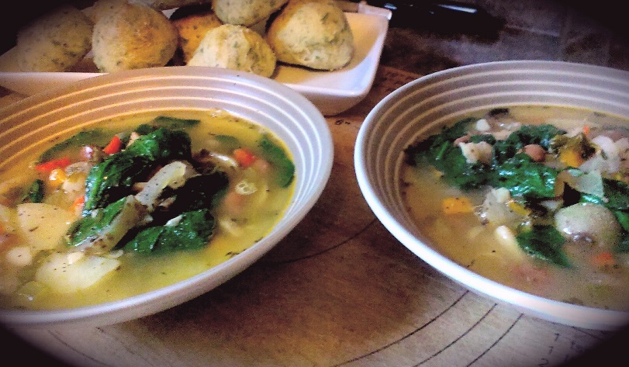
- Combine water, yeast, and sugar in a large mixing bowl for 5 minutes or so until the top is foaming.
Using a food processor, combine the flour, parsley, oregano, basil, and sea salt. Slowly pour in the yeast/water while the processor is running. Remove the dough and transfer to a floured surface, knead a few times and transfer to a lightly oiled bowl with a clean towel over top.
After approximately 20 minutes, dough should be ready to use or refrigerated until ready to use (same day)

- In a large sauce pan, bring to temperature on medium and add the olive oil, onion, celery, and bell peppers. Give 2 pinches of sea salt and fry for 5 minutes. Stir in the mushrooms, potatoes, and garlic and give another pinch of sea salt. Allow to cook for 4 – 6 minutes.

- Mash ¼ of the beans using a fork. To the sauce pan add the mashed and whole beans, thyme, parsley, bay leaves, and vegetable stock. Sprinkle about a Tsp. and ½ of Sea Salt and 1 Tsp. Black pepper. Bring to a boil on medium stirring often. Cover and reduce to medium low for 10 – 15 minutes.

- Preheat oven to 425 F

- Divide the dough into 8 equal portions on a floured surface. Knead each piece a couple times and shape into a bowl. Line on a lightly oiled baking sheet and bake for 11 – 13 Min. Remove from oven and brush with EV olive oil. Sprinkle with grated parmesan and sea salt.

- Add the spinach to the soup and a pinch of sea salt and cook another 5minutes. Ready to Veg Out!

