Italian style Beans and Veenies
Grocery List
- 5 Jumbo Veggie Hot Dogs ***(Yves Veggie are perfect)
- ½ Tsp. dried Basil
- ½ Tsp. dried Parsley
- ¼ Tsp. dried, minced Onion
- 3 to 4 Tbsp. EVOO

- ¼ C EVOO
- 1 Yellow Onion, diced
- 3 cloves Garlic, chopped
- 1 C Tomato Sauce
- 540ml can Cannelini Beans
- ¼ C fresh Parsley, roughly chopped
- 1 Tbsp. Fresh Basil, chopped
- Sea Salt / Black Pepper

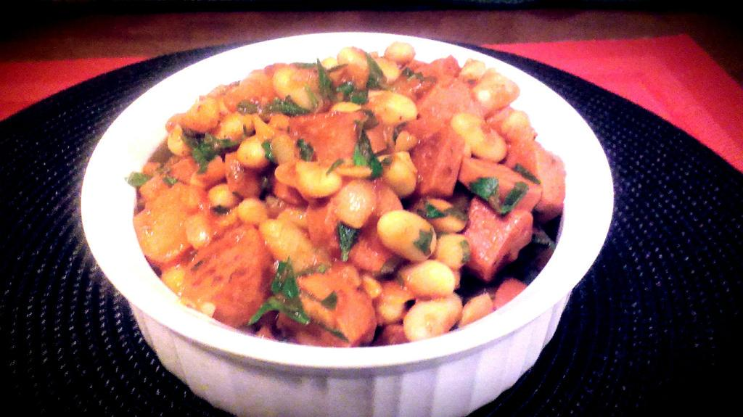
Prep Time: 20 Min
Cook Time: 30 Min

- Bring a medium sized pot of cold water to a boil on medium high heat. Add the hot dogs and cook for 5 minutes. Strain and slice the hot dogs.

- In a large frying pan, bring to temperature on just below medium and pour in the ¼ C EVOO. Heat briefly before adding the onions and a good pinch of sea salt and black pepper. Fry 3 or 4 minutes before adding the garlic. Stir often for another 3 minutes.

- In a separate medium sized frying pan, bring to temperature on just below medium and pour in the Tbsp.’s of EVOO. Swirl around the pan and add in the sliced hot doggies. Sprinkle in the dried herbs / onion and a pinch of sea salt / black pepper. Stir together constantly for 5 minutes browning the hot dogs on all sides. Set aside covered.
**Veggie dogs cook / burn quickly so it’s important to watch them and stir / flip often to avoid over cooking or blistering.

- Add the cannellini beans to the pan with the garlic / onion. Stir to combine and fry for 2 or 3 minutes stirring often. Pour in the tomato sauce and bring to a boil. Reduce heat to medium low and cover for 6 – 8 minutes before stirring in the fried hot dogs. Cook together covered another 5 minutes. Taste and adjust sea salt / black pepper accordingly.

- Stir in the fresh, chopped herbs and remove from heat.

- For each individual serving, garnish with fresh parsley. Shredded Mozzarella is delicious as well!

