Black Beans and Rice
Grocery List
- 1 ½ C Long Grain White Rice
- ½ 796 ml can Diced Tomatoes
- 10-15 Halved Grape Tomatoes
- 1 590 ml can Black Beans, drained and rinsed
- 2 ½ C Low Sodium Vegetable Stock
- Olive Oil (for frying)
- Tbsp Unsalted Butter
- Medium Red Onion, diced
- ½ Yellow Onion, diced
- 3 cloves Garlic, chopped
- Salt / Pepper
- Pinch Dried Oregano
- ½ Tbsp Cumin
- ½ Tbsp Cayenne Pepper
- Fresh Cilantro, chopped
- 3 or 4 Green Onions, diced (light and dark green parts)

Prep Time: 20 Min
Cook Time: 35 Min

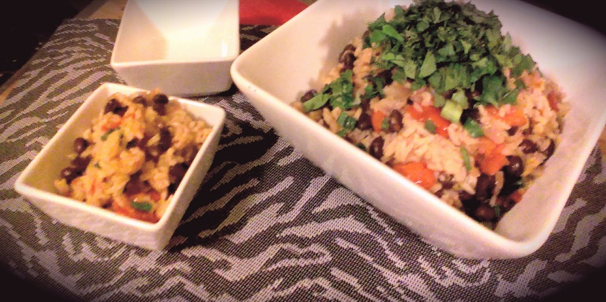

- Coat a large frying pan in olive oil and toss in the butter, heat on medium.

- Add the onions and a pinch of salt and fry for 5 minutes, stirring often. Add in the garlic and fry for another 2 minutes. Stir in the rice and continue cooking for 5 minutes stirring often. (Don’t let the rice burn.)

- Add the stock, tomatoes, beans, oregano, cumin, cayenne, and a couple cracks of pepper /sea salt. Bring to a boil on high heat. Reduce heat to low – medium and cover. Simmer for 25 minutes stirring occasionally. (TASTE TEST after 20 minutes and check for crunchy bits, add stock / tomato juice if needed.)

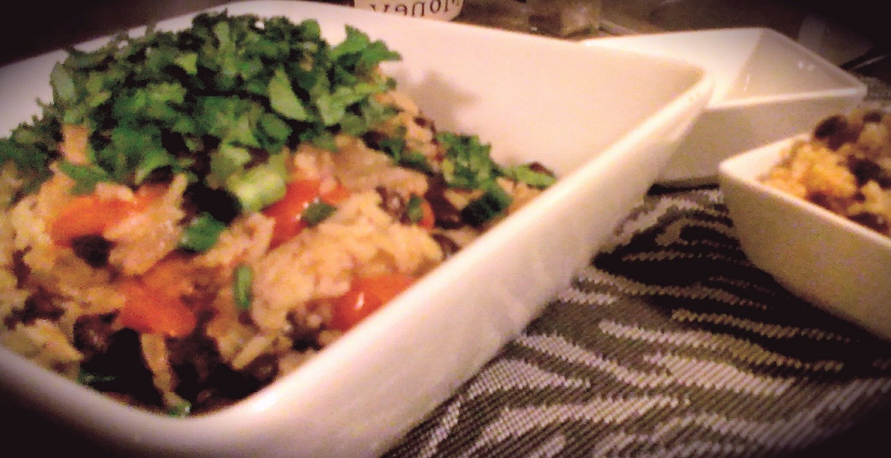
- Remove from heat and stir in chopped green onions. Transfer to service bowl and garnish with chopped cilantro.

