Rotini in a Garlic and Herb Butter Sauce
Grocery List
- 3 Cups Rotini Pasta
- 1 Cup Pasta Water
- 2 Tbsp Olive Oil
- ½ C Unsalted Butter
- ½ C Shredded Mozzarella
- ¼ C Shredded Parmesan
- ½ C Frozen Peas
- 4 Cloves Garlic, minced
- ½ Red Onion, diced small
- 3 Tbsp chopped Fresh Parsley
- 2 Tbsp chopped Fresh Basil
- Salt / Pepper

Prep Time: 15 Min
Cook Time: 20 Min
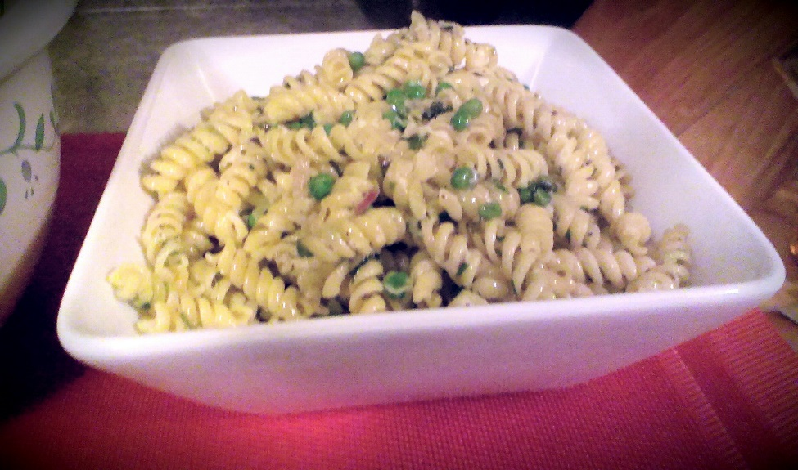
- Bring 4 Cups of water to a boil on high heat. Add in the pasta and cook following the package directions. (Approximately 8 Minutes.) Keep 11/2 cups of pasta water and strain the noodles.

- In a large frying pan, heat the oil and butter on medium heat and add the onions. Give a dash or 2 of salt and Fry for about 7 minutes stirring often. Add the garlic, cook for another 3 minutes.

- Add in the peas, pasta water, pasta, shredded parmesan, and basil. Stir to combine and heat together for another 5 minutes or so. Salt and Pepper to taste.
*If there is not enough “butter sauce” you may add more butter 1 Tsp at a time, counter it with 1 Tsp of pasta water.

- Remove from heat, stir in chopped parsley and shredded mozzarella. Transfer to serving bowl and serve immediately. (Make sure to drizzle your pasta with what’s leftat the bottom of the frying pan.)

- Garnish with fresh parsley and shredded parmesan.

