Cheddar Mac N Cheese
With Jalapeno and canned Green chili’s
Grocery List
- 2 ½ C uncooked Macaroni noodles

- ½ C shredded Marble cheddar
- 1 ¾ C shredded Old Cheddar
- ¾ C Heavy Cream
- 1 ¼ C 2% Milk
- 3 Tbsp. AP Flour
- 3 + 1 + 1/2 Tbsp. unsalted Butter
- ¾ Tsp. Sea Salt +
- ½ Tsp. Black Pepper +

- 127ml can diced Green chili’s
- 1 Jalapeno, seeded and diced

- 2 Tbsp. Bread Crumbs

Garnish with Paprika and fresh Parsley

Prep Time: 15 Min
Cook Time: approx. 50 Min
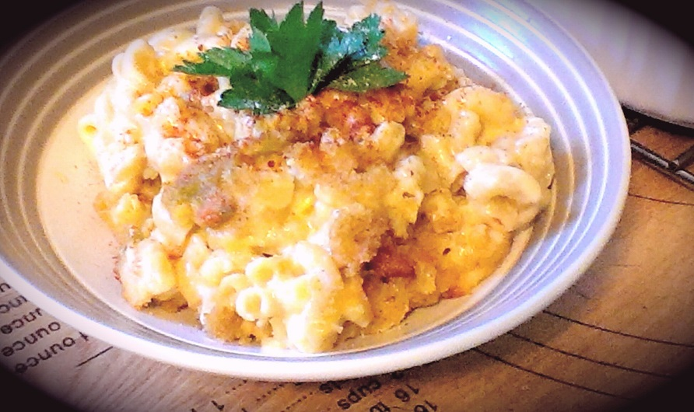
- Bring a large pot of water to a boil on high heat. Give a generous pinch of sea salt and add the noodles. Cook to al dente according to package directions and strain either setting in an iced bath or running under cold water to stop cooking.

- In a small frying pan, bring to temperature on just under medium and add in 1 Tbsp. of butter. Add in the diced jalapeno and allow a minute or two to cook. Stir in the canned chili’s and give a pinch of sea salt / pepper. Fry for about 5 minutes, cover and remove from heat.

- In a large sauce pot, bring to temperature on medium and add in the 2 Tbsp. butter. Stir in the AP Flour, ¾ tsp. sea salt and ½ tsp. pepper. Continue cooking on medium stirring constantly for about 5 minutes.
(You want the roux to have the starchy, flour taste cooked away but want to avoid darkening the roux as it will affect the colour of your mac n cheese!)

- Slowly pour the milk and cream into the pot of roux stirring throughout the entire pour. Bring to a boil on medium and allow to boil a minute or two before adding the cheese in small batches, stirring it in each batch.

- Once the cheesy sauce has been fully combined, stir in the noodles. Mix together to evenly coat all the noodles in the sauce. Remove from heat.

- Preheat oven to 400 F

- Using a 1 ½ qt circular baking dish, fill with ¼ of the mac and cheese. Using a Tbsp. sprinkle some of the chili mixture evenly over the layer of mac. Sprinkle with sea salt and black pepper. Continue until pasta and chili mixture is finished with the chili layer being the top layer.

- Sprinkle with the bread crumbs and bake for 10 Minutes covered and 10 – 12 Minutes uncovered until brown and crispy on top.

- Garnish each serving with paprika and / or parsley for colour.

