Cheesy Tomato Tortiglioni
Grocery List
- ¼ C EV Olive Oil
- 1 Yellow Onion, diced
- 1 Medium Carrot, peeled and diced
- 4 cloves Garlic, chopped
- 10 Santalina Grape Tomatoes, quartered
- ½ C low sodium Vegetable Stock
- 796 ml can Diced Tomatoes, half the juice strained
- 454g box Tortiglionii Pasta
- ½ C chopped fresh Parsley
- ¼ C chopped fresh Basil
- 1 C fresh Baby Spinach
- 1 C shredded Mozzarella
- Sea Salt, Black Pepper, Dried Parsley

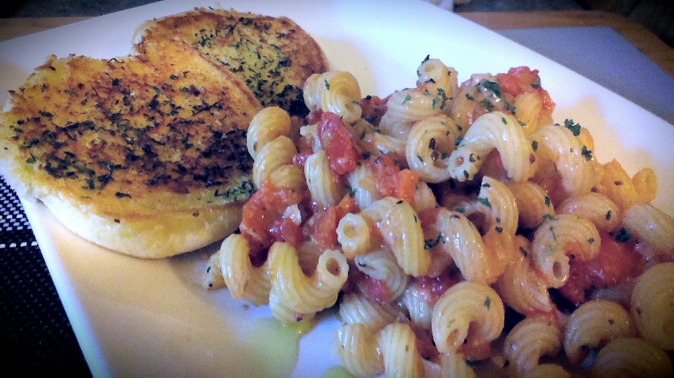
Prep Time: 25 Min
Cook Time: 35 Min

- Bring a large frying pan to temperature on medium heat. Pour in the oil and add in the diced carrots and onions. Give a pinch of sea salt and stir. Cook for about 5 minutes stirring often.

- Stir in the garlic and continue frying another 2 minutes. Add in the quartered tomatoes and another pinch of sea salt. Stir together and cover for about 4 or 5 minutes.

- Pour in the vegetable stock and bring to a boil. Pour in the canned diced tomatoes, parsley and basil, ½ tsp. sea salt and a ¼ tsp. black pepper. Stir and bring back to a boil. Cover and reduce heat to medium low.

- Bring a large pot of salted water (4L ) to a boil on high heat. Add in the Cavatappi and cook Al Dente following package instructions. Using a slotted spoon, transfer the noodles to the sauce allowing some pasta water to be transferred to the sauce as well. Toss together and add in the spinach. Cover and cook for about 6 – 8 minutes stirring occasionally.

- Remove from heat and stir in the shredded mozzarella, cover and let stand 5 minutes.

- For service, drizzle with Olive Oil and sprinkle some fresh or dried parsley over the pasta.

