Cheesy Avocado Ranch Potato Salad
Grocery List
- 10 - 12 small to medium sized Red Potatoes
- 2 Green Onions, sliced
- ½ pint Grape Tomatoes
- ½ C. Monterey / Cheddar mix, shredded on large grate

- ¾ C Mayonnaise
- 2 Tbsp. Whipping Cream
- 1 ½ Tbsp. Low Fat Sour Cream
- 1 Tbsp. Ranch Dressing
- 1 Avocado, mashed
- 1 Tbsp. Green Pepper Sauce
- Sea Salt / Black Pepper

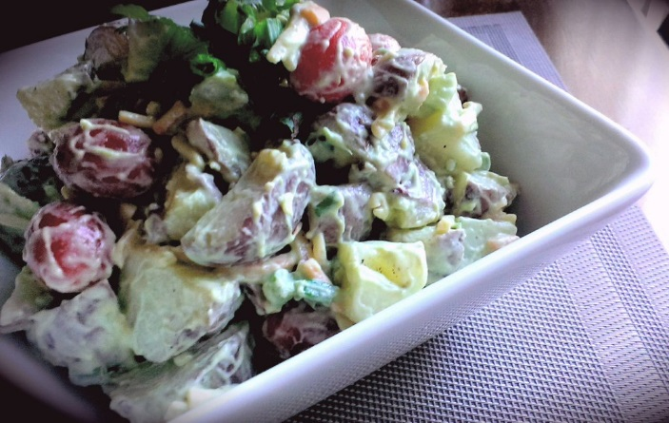
Prep Time: 12 – 15 Min
Cook Time: 16 – 20 Min
Chill Time: 30 Min +

- Bring a large pot of cold water to a boil on medium high heat and season generously with sea salt. Scrub the potatoes and add to the pot. Boil partly covered 16 – 20 Min until tender but not fully cooked and crumbly. Strain and rinse thoroughly with cold water to cool.

- In a small mixing bowl, combine all ingredients for dressing including a pinch of both sea salt and black pepper. Use an IMMERSION BLENDER to thoroughly blend the ingredients until rich and creamy.

- Halve the potatoes lengthwise and again lengthwise leaving 4 potato sticks. Slice each “stick” into 3 or 4 cubes depending on size of potato.

- Add the potatoes to a large mixing bowl along with the tomatoes and half the green onions. Season with a pinch of salt. Pour half the dressing over the potatoes and toss together. Add the remaining onions, shredded cheese, and add more dressing to your own tastes. Toss again. Taste and adjust salt / pepper if necessary.

- Refrigerate 30 Min + prior to service.

