Cheesy Mexi Pasta Bake
Grocery List
- 3 ½ C uncooked Pasta Shells
- ½ C Black Beans
- 1 Jalapeno, seeded and diced
- 1 Mini Sweet Pepper, halved, seeded, and sliced
- ½ Red Onion, sliced
- 2 Green Onions, light and dark green parts, sliced
- Sea Salt / Black Pepper
- ¼ C shredded Old Cheddar

CHEESE SAUCE

- 1 heaping TBSP. unsalted Butter
- 2 Tbsp. AP Flour
- 1 ¼ C 2% Milk
- 1 C Shredded Old Cheddar
- ½ Tsp. Sea Salt
- ¼ Tsp. Black Pepper

Prep Time: 15 Min
Cook Time: 50 – 60 Min
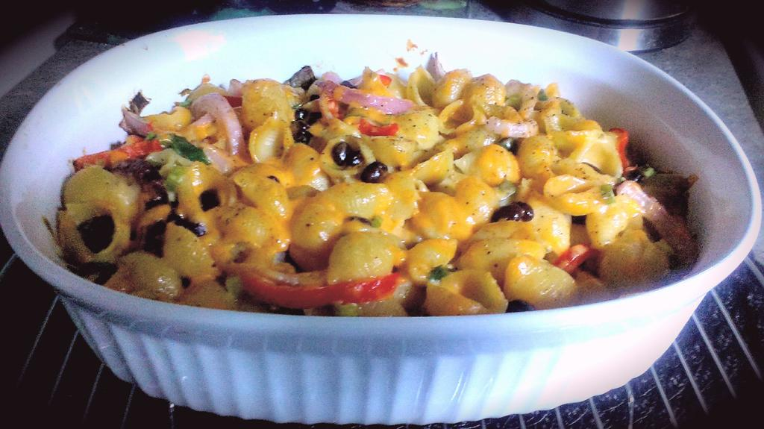
- Bring a large saucepan filled with cold water to a boil on medium high heat. Salt the water upon boiling and add your pasta. Cook to al dente following package directions. Strain and rinse under cool water. Set aside.

- Preheat oven to 350 F

- In a medium sized saucepan, melt your butter on medium heat. Stir in your flour and reduce the heat to medium low. Stir often and allow the mixture to bubble but watch to make sure it does not brown or burn.

- Remove from heat and whisk in the milk. Once combined, return to burner and increase heat to medium. Season with the salt / pepper. Once the sauce starts to gently boil and thicken, stir in the old cheddar in 2 batches until the mixture is fully combined and cheese is melted. Reduce heat to low and allow to continue cooking another 2 or 3 minutes.

- Stir in the cooked pasta, black beans, jalapeno, sweet pepper, and red and green onions. Cover and allow to heat another 3 minutes on low stirring once.

- Transfer to a 2 ½ QT baking dish. Bake covered for 35 – 40 minutes before removing the cover and continuing to bake another 5 – 8 Min. (just enough to lightly brown the top)

- For service, garnish with sliced green onion. Try a dollop of sour cream, your favourite hot sauce, or even your favourite salsa!

