Cranberry Apple Crisp
Grocery List
- 6 Granny Smith Apples, peeled, cored, and sliced
- 2 C fresh Cranberries
- Juice of 1 Lemon
- ¼ Tsp. Cinnamon
- ¾ C White Sugar
- 1 ½ Tbsp. Corn Starch

- 1 ½ C Rolled Oats
- 1 C Brown Sugar, packed
- 2 heaping Tbsp. AP Flour
- ½ Tsp. Ground Cloves
- ½ Tsp. Salt
- 3 Tbsp. Unsalted Butter, room temperature

- 1 Tbsp. Unsalted Butter, room temperature

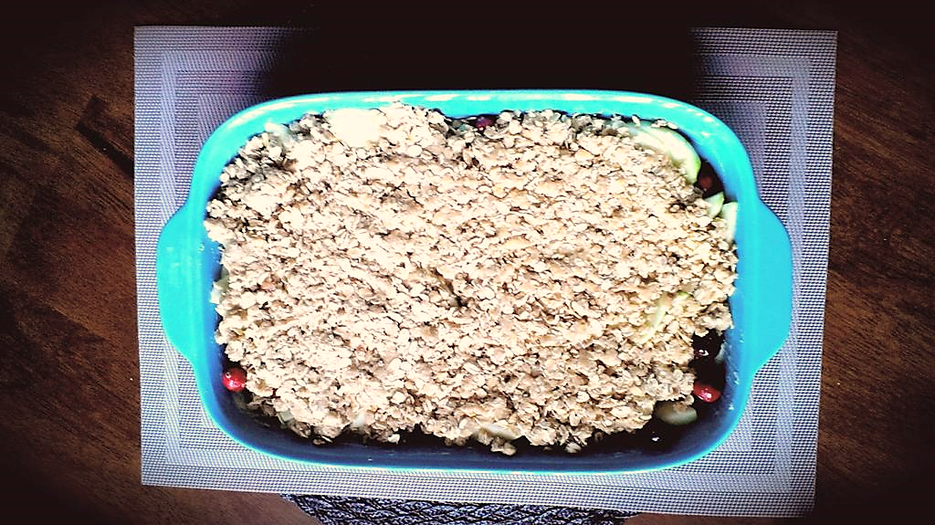
Prep Time: 15 Min
Cook Time: 55 – 60 Min

- Combine the apples, cranberries, lemon juice, sugar, corn starch, and cinnamon. Stir to fully combine all ingredients and set aside.

- In a medium sized mixing bowl, combine the oats, brown sugar, flour, cloves, nutmeg and salt. Add the butter 1 TBSP. at a time working it into the mixture with a fork until all butter is fully incorporated and mixture is crumbly and buttery. (Using your fingers to mix the butter into the mixture is very fun and works well too!)

- Preheat oven to 375 F

- In a 2 ½ qt. baking dish, use a piece of parchment paper to smear the butter across the inside of the dish entirely. Pour the fruit into the dish and gently press it down. Pour the crumb mixture to cover the entire dish.

- Bake for 55 – 60 Min until brown on top and nice and bubbly.

- Cool 5 minutes before serving.

- Serve with a scoop of Vanilla Bean Ice Cream.

